 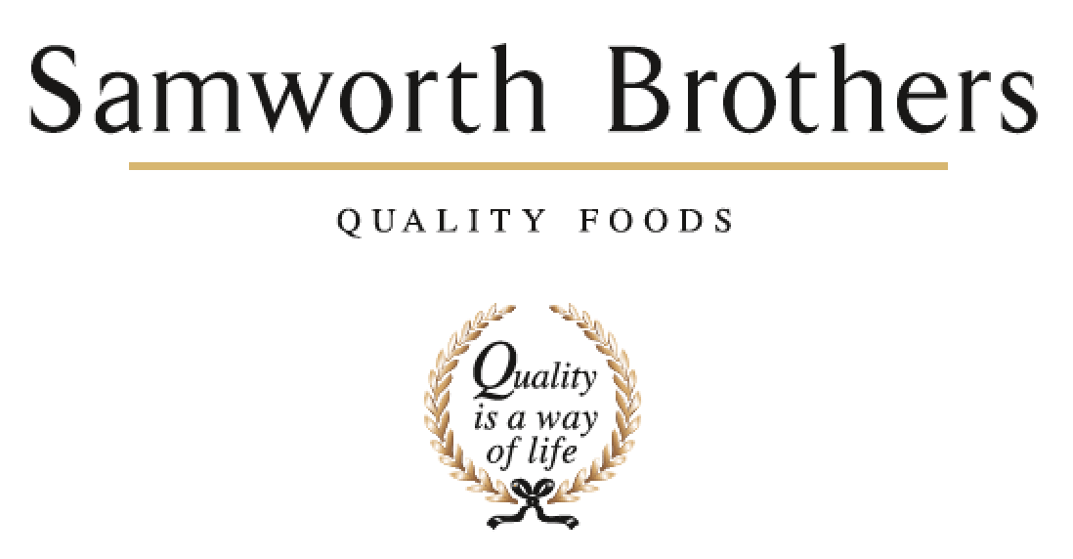

|  |  |  |  |
| --- | --- | --- | --- |
| **ROLE PROFILE** | | | |
| Job title | Area Manager | Date | 09/12/2024 |
| Department | Operations | | |
| Location | Soreen Trafford Park | | |
| **ROLE SUMMARY**  Summarise in **one or two sentences** the highlights of the job in terms of its purpose and overall responsibility. | | | |
| A Technical Expert who both operates and oversees all equipment, processes and people in their area.  Takes 1st Line Manager responsibility for all aspects of Safety, Quality, People, Delivery and Cost for their Line(s) whilst on shift, ensuring compliance with legislation, company standards and budgetary constraints. | | | |
| **REPORTING STRUCTURE** | | | |
| Reports to | Production Manager | | |
| Key internal stakeholders | Technical, Engineering, HSE, Supply Chain, People team, Finance | | |
| Key external stakeholders |  | | |
| KEY ACCOUNTABILITIES AND RESPONSIBILITIES | | | |
| **Safety**   * Meet all individual and role responsibilities as required under the Company Health and Safety policy to meet legal compliance. * Proactively promote our Safety-first Culture, be responsible for your own safety and for others, influencing good behaviours. * Ensure risk assessments are carried out to address any potential hazards, ensuring the assessments are current and effective. * Ensure employees follow Safe Operating Procedures, and ensuring the correct personal protective equipment is worn when required. * Ensuring the correct use of any equipment. All relevant training is carried out, and trainee deemed competent to carry out the task. * Accidents, incidents, near misses and hazard spots are investigated in a timely manner and good use of improvement techniques to identify route cause, introduce preventative measures to stop recurrence. * Department audits to be carried out to identify potential failings in the system, and act on findings.   **People**   * Complete return to work meetings with staff * Conduct disciplinary investigations to level that allows appropriate progression * Inspire confidence and ensure that staff are competent and sufficiently trained for tasks undertaken. * Supervise staff to ensure that they are carrying out tasks to the required level in line with Soreen processes, procedures and standards * Create a training plan for staff based upon role profiles, skills matrices and SOPs, supporting the writing of documents where required. * Demonstrate and promote integrity and ensure that the team treats each other respectfully and equitably in line with Soreen values.   **Quality**   * To ensure that all product and processes are compliant with site product and technical standards * To ensure that Bakery Operating and hygiene standards are compliant or exceed BRC standards * To ensure that all required documentation is completed fully and accurately, within the required timeframes and submitted as needed. * To ensure that all staff are compliant with personal hygiene site standards * To ensure all production activities are compliant with legislation including HACCP, Weights, labelling etc.   **Delivery**   * Ensure that materials (including rework) are correctly collected, consumed and stored, with traceability as required and specified, used in rotation and with correct process control. * Ensure that all mixes are used with correct recipes, and are weighed and mixed correctly, as per specification. * Ensure that all Plant and Equipment within area of control is set and operating correctly for the product being run. * Ensure that WIP is stored, labelled and rotated correctly, compliant with procedures. * Ensure that the Production Plan is being followed and that the orders are fulfilled as specified. * Ensure that all finished product is packed, coded, labelled and cartoned as per specification, is fit for sale and legally compliant. * Ensure that all finished product is recorded accurately, not creating ghost pallets.   **Cost**   * Ensure that the areas for which you are responsible are staffed as per the standard template. * Ensure that deposit weights are set accurately so that there is minimal lightweights and giveaway. * Ensure that Plant speeds match budgeted standards. * Minimise all waste throughout the Plant (including rework), understanding the root cause, generating remedial actions. Waste to be cleared on the shift on which it has been created. Reconcile yields for each production run. * Reconcile actual labour cost against Budget labour cost | | | |
| QUALIFICATIONS, EXPERIENCE, TECHNICAL SKILLS / KNOWLEDGE List the skills gained through education and experience required to effectively function in the position | | | |
| **Essential Skills / Experience:**   * Supervisory experience. * Experience of working in a food manufacturing environment. * Able to follow written and verbal instructions. * Excellent attention to detail. * Positive, flexible attitude. | | | |

|  |  |
| --- | --- |
| **ATTRIBUTES & BEHAVIOURS FOR SUCCESS** | |
| **Behaviour** | **Descriptors** |
| **Focused on developing people** | * Consistently demonstrates that people are the top business priority. * Devotes a significant % of time to supporting and coaching their people. * People related activities are consistently placed high on the “to do” list. * Always make themselves available to support team members, regardless of how busy they are. |
| **Builds strong relationships** | * Demonstrates they are a good listener who can take on board other points of view. * Demonstrates trust in other teams and other colleagues. * Displays a high level of emotional intelligence to understand how to improve a relationship. * Willing to be the “better person” for the sake of building or maintaining a relationship. * Consciously aware of key relationships which require more work to improve. |
| **Courage to make tough decisions** | * Demonstrates they can make a positive decision when none of the alternatives are attractive. * Is able to make quick decisions when needed even if the data is not complete. * Is able to take the “hard / right” decision (which will upset some people) rather than always opting for the “easy / but wrong” decisions. * Consistently demonstrates high standards and does not drop standards just because the implications are challenging. |
| **Calmness during challenging times** | * The more challenging the situation the calmer we want our people to be. * Does not get over-emotional when things go wrong. * Recognises that challenging times call for the best kind of leadership. * Focuses on the issue…….not the person who made a mistake or who discovered a problem. |
| **Leads by example** | * We should “walk the walk” as well as “talk the talk”. * Displays a consistent approach in how they deal with everyone in the business regardless of their level. * Demonstrates an unshakeable positive attitude regardless of how challenging the circumstances. * Appreciates the views of everyone in the business and welcomes new ideas and challenges. |