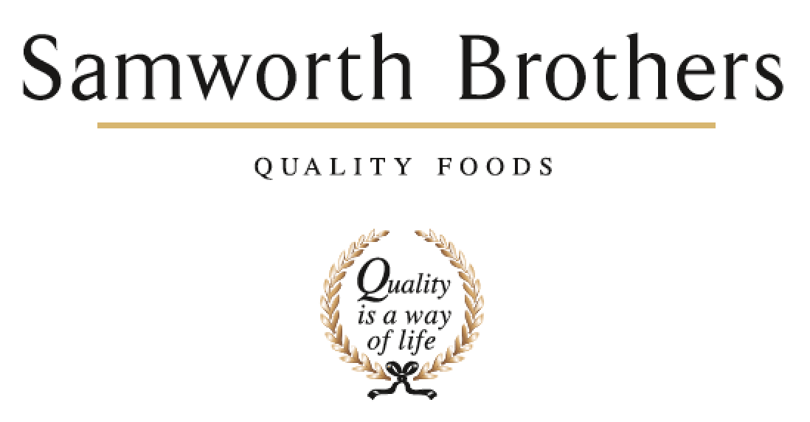

|  |  |  |  |
| --- | --- | --- | --- |
| ROLE PROFILE | | | |
| Job title | People Partner | Date | April 2024 |
| Business | Walkers Deli and Sausage Co | | |
| Department | People Team | | |
| Location | Cobden Street, Leicester | | |
| ROLE SUMMARY | | | |
| The People Partner delivers proactive and flexible generalist People support to improve business performance and deliver value-add People plans in line with the Samworth Brothers Purpose, Culture & Values.  As a Senior Manager, you will sit on the site senior management team and act as a strategic partner to your business area, shaping People plans which enable the business to align to opportunities, supporting change and furthering the talent agenda to build high performing teams and develop excellent leaders and managers.  You will take a keen interest in the key business performance measures, understanding how you can support, influence, and drive these areas. You’ll be able to deploy and interpret key People metrics, data, insight and explain what they mean for business performance.  Your business area looks to you as the professional expert in People matters, and you will offer coaching and guidance as well as strategic direction. You’ll be instrumental in ensuring that the business delivers results with People at the heart of the agenda, and that every decision and action is taken with the Colleague experience as a key consideration. | | | |
| REPORTING STRUCTURE | | | |
| Reports to | Head of People (Protein) | | |
| Deputy |  | | |
| Direct & indirect reports | People Advisor, People Admin | | |
| Key internal stakeholders | Operations, Engineering, Hygiene, Shared functions | | |
| Key external stakeholders |  | | |
| SKILLS & ABILITIES | | | |
| * Collaborate with the People Leads community on projects to collectively deliver our purpose of ‘Doing GOOD things with GREAT food’ for all of our colleagues; ensuring we welcome all colleagues into our family and providing opportunities for all of our people to grow, improve their prospects and achieve their full potential. * Work in partnership with the leaders and managers of the business to build a values-based culture, delivering the Culture Framework and ensuring that business results are achieved with people at the heart of every decision and consistent focus on providing a positive experience for Colleagues. * Partner with line managers and senior teams to ensure that all business activity is supported by guidance from the People team that is commercially focused and aligned with group values and ways of working. * Represent the People Team at various site level/senior management meetings, and seek to fully engage these multi-functional teams in identifying, supporting, and delivering strategic and commercial plans in alignment with the People strategy. Use these platforms to drive momentum on strategic People plans, providing regular updates and influencing when key decisions are being made that impact our Colleagues. * Deliver the People strategy in the business, ensuring that all people activities across the employment lifecycle are executed in ways which add value to both the business and the Colleague experience, with the People vision in mind. Pro-actively support projects to fully embed our strategic ‘enabler’ ways of working in the business. * As required, identify any other tasks, projects, duties, and work streams which contribute to the success of the People Team in supporting the business in day-to-day people management activity and in delivering on the objectives of the agreed annual strategic People plan. * Play a pro-active role in managing change to assist the business in achieving its goals whilst upholding our values and maintaining a positive experience for colleagues. Provide guidance and insight on the People aspects – capabilities and skills, labour patterns and pay, ways of working, engagement, and sentiment, and work with change management teams to shape and deliver positive and effective change plans. * Play a key part in encouraging diversity and respectful inclusive behaviours, identifying and removing barriers to equality. Act as a role model by ensuring own knowledge is current, managing own biases and behaviours and providing guidance to others. * Promote colleague wellbeing, both as an ethical priority and as a key factor in colleague performance, satisfaction, and retention. * Manage the implementation of the internal communications strategy for the business to create a strong sense of belonging and identity for Colleagues, and ensuring key information is effectively shared. * Deliver and follow up the annual Colleague Engagement Survey to realise its full advantage: maximise response rate, gather quality feedback and analyse response data to shape and drive action plans which increase overall colleague engagement, wellbeing, and satisfaction. * Assemble and manage the Consultative Committee in a way which facilitates meaningful two-way discussion and builds trust, in line with group procedures and ways of working. * Embed and promote the Performance Enhancement process as a key foundation of colleague development and engagement, encouraging managers to coach and support high performance and progression, and colleagues to fully engage and take ownership of their own development journey. * Support senior and line managers with preparing for talent mapping and succession planning activities. Lead and facilitate on these, ensuring they are fit for each business area forward planning and working with management teams to identify high potential colleagues and those of concern, as well as overall trends, and to create appropriate action plans. * Work collaboratively with the L&D team to partner with leaders and senior managers, coaching them to develop high performing teams and support individual colleague progression. Promote our L&D tools and opportunities, and seek to remove any barriers to learning and development. * Support on-site training and development activity, playing an active role in ensuring full compliance with required training elements and engagement with early careers, apprenticeships, Culture Framework related training, etc. Support the L&D Partner to shape and manage the annual L&D budget and plan for the business. * Support senior and line managers to address any instances of underperformance in a timely manner, with clarity, taking a constructive approach. * Oversee recruitment for Monthly and Weekly paid roles, encouraging People team and recruiting managers to effectively liaise with the central Resourcing team adhering to agreed processes, and ensuring that candidates experience our business positively. Support with selection and interview for senior roles as required. Be responsible for ensuring onboarding and offboarding is effective and a positively impactful experience for the colleague. * Liaise with temporary worker agency and off-payroll worker agency, playing an active part in ensuring that workers have a positive onboarding and working experience, and that the business adheres to agreed processes and ways of working. * Be responsible for managing the pay cycle (PRP, pay reviews) and promoting the benefits and broader reward package, as well as identifying any business-specific pay / incentive requirements and progressing these through group approval and implementation. Ensure payroll processes are adhered to, encouraging a constructive relationship between Payroll and People teams. * Manage complex colleague relations issues within your business area, connecting with any high-risk cases. Coach and provide guidance to People team and line managers to improve capability and to ensure cases are managed effectively and constructively, and with sensitivity to the colleague experience. Monitor attendance and absence, disciplinary and grievance issues and identify emerging trends and issues, ensure follow-up action is taken to address any contributing factors in the business context. * Utilise and analyse MI and data to inform People related decisions and activity, enhance stakeholder engagement and evidence business progress and ROI. * Lead, or support on, preparation for and delivery of internal and external audits including Ethical audit and routine customer and governing body audits and close out any People-related non-conformances in a timely manner. Ensure that People team activities are compliant and run to ‘audit ready’ standards including maintenance of accurate data on the Sedex Advance and Marks & Spencer Supplier Information Systems. * Ensure that People systems, information and data are accurate, up to date, and managed and held in a format which follows current legislation (e.g. GDPR) and customer standards / codes of practice. * Manage the People team to provide effective and efficient People partnering support to the business, it’s line managers and colleagues, working in alignment with the group Purpose & Values, People strategy and business’ People plans. Coach and develop your direct reports, delegating work as appropriate to provide stretch and challenge whilst fully managing any potential risk to the business and individual. * Actively engage with reliable sources to update and enhance own knowledge and understanding of new developments, best practice and fresh perspectives in the marketplace, industry, and the People profession. | | | |
| KNOWLEDGE & UNDERSTANDING | | | |
| * Understands how values-based business leadership with clear purpose develops a positive culture and underpins strong business performance. * Knows the Samworth Brothers Purpose & Values, how these were conceived and have evolved as the group has grown and developed over the years. * Is fully conversant with the Culture Framework, it's function as an enabler of the Purpose & Values, and how it is delivered in the business. * Understands how to effectively deliver training, facilitate learning, and lead a group session to upskill, inform and inspire. * Has solid business acumen - understands the way business operates and how the moving parts, including people aspects, work together to make it successful. Knows how to read the progress of the business through its financial metrics and has awareness of the levers, risks and opportunities which impact profitable growth. * Understands the dynamics of the senior management team and how the People Partner role in this context contributes to broader business strategy and influences decisions beyond the People agenda. * Knows how to effectively communicate, influence, and work collaboratively with colleagues and stakeholders at all levels of the organisation, including how to provide feedback and positively challenge when necessary. * Takes a coaching approach with colleagues and internal stakeholders, empowering others to deliver results and develop understanding through personal accountability. Can clearly articulate the methodology and models behind this approach and apply appropriately according to the individual person and circumstance. * Maintains an up-to-date knowledge of key legislation, precedents and best practice (employment, ETI Base Code, GDPR, Samworth Brothers policies & procedures, etc) and has a good awareness of other areas relevant to SB business operations (food safety, H&S, finance, etc). * Is fully conversant with the Samworth Brothers People Toolkit - policies, processes, learning & development programmes, etc and their relevance to business operations and objectives. * Is conversant with the language, terminology and structure of legal contracts, service level agreements, etc., and understands where it is appropriate to seek specialist advice in developing, negotiating or agreeing these. * Can structure, build, and deliver a presentation in a way which effectively conveys the message, engages the audience, and garners support for the proposal. * Can build and structure change processes, taking into account business objectives, legislative and procedural requirements, and colleague experience / engagement. * Understands how to deliver business change plans, including communication and consultation with individuals, larger audiences, and key stakeholders, ensuring that a planned and co-ordinated approach results in effective and timely outcomes. * Understand drivers of, and barriers to diversity & inclusion, and mechanisms of individual bias and how to mitigate and positively challenge. * Understands the importance of colleague wellbeing in overall engagement and performance, and the positive impact on wider business results. Is fully conversant with the various physical, mental, and emotional factors contributing to resilience and wellbeing, and how these are supported / impacted in the business operation. * Is fully conversant with the Samworth Brothers Wellbeing strategy, it's function as an enabler of the Purpose & Values and overall business performance, and how it is delivered in the business. * Has a good working knowledge of how to deliver an effective internal communications strategy with clarity and objectivity. Understands key factors such as audience segmentation, available channels, and basic marketing principles. * Understand the key factors which affect employee engagement, and the ways in which business can create the conditions in which colleagues will offer more commitment and capability. * Is conversant with the Information and Consultation regulations and best practice, the purpose of colleague forums and how these are delivered across Samworth Brothers and can tailor the approach to take account of the demographics and audiences, business operations and objectives in their business area. * Fully comprehends the Samworth Brothers organisation design as set out in the Career Pathways, L&D Pathways and Ways of Working, and is fully conversant with how these structures, roles and capabilities are applied within own business area ensuring that any new roles or strategic changes continue to reflect alignment with them. * Is fully conversant with the Samworth Brothers Performance Enhancement and Talent & Succession toolkits, their function as an enabler of colleague development and engagement in line with the People Vision and overall business performance, and how these are delivered in the business. * Appreciates the differences between intrinsic vs extrinsic motivation, the factors which drive and sustain these, and how these are embedded in the People policies and practices. * Be fully conversant with the content of L&D Pathways for each Job Family, understanding the capability levels and skills gaps in own business area to agree areas for strategic L&D focus and programmes to support business objectives. Contribute and give feedback as these L&D Pathways are reviewed and updated. * Understands the role of L&D Advisor and L&D Partner, and has an up-to-date knowledge of induction and compliance training requirements for business area, as well as any key capability gaps. * Can articulate the features of a fair, effective, and equitable recruitment and selection process from job role planning through to screening, interviewing, and profiling candidates and has the knowledge to support and guide managers through these steps. * Has appropriate knowledge and understanding of auditing procedures to carry out audits of internal process and of agency labour providers. * Has full knowledge of the SB pay and benefits, contract of employment terms & conditions (e.g., shift patterns) as well as relevant legislation (e.g., Working Time Directive) and how these are applied and managed in the business. * Understands the importance of taking a 'mediation and resolution' approach to employee relations, has the knowledge to manage cases this way in practice and to role model / coach this approach to others. * Demonstrates solid knowledge of critical thinking and objective decision-making methodology. * Knows how to select, analyse and interpret data and ways in which results can be effectively presented to others. Understands how to set measurables (KPI's, objectives, etc) in a way which drives performance and demonstrates progress. * Knows the Samworth Brothers business processes and procedures which must be adhered to for safety, quality and legal compliance e.g., Health & Safety procedures, Group Authorities Manual. * Has a good working knowledge of the relevant sections of Customer codes of practice and other audit standards which are applicable to people management and People Team operations. * Understands how to effectively manage external stakeholders and auditors, in line with our Samworth Brothers Values. * Has full working knowledge of the key information systems used by the People Team - People Portal, clocking & attendance, AX, Sharepoint, etc. * Understands how to manage a people function within the wider business context, including the factors which build positive reputation and influence. * Has the knowledge to underpin strong people management skills e.g., how, and why to lead with vision and empathy, delegation, and time management, developing others. * Knows how to select and evaluate different sources of information to ascertain reliability and relevance, and understands how to introduce new learnings into the Samworth Brothers context in ways which best add value. * Understands the importance of continued personal and professional development (CPD). | | | |
| QUALIFICATIONS & EXPERIENCE | | | |
| CIPD L5 People Management   * Business Partner at senior management team level * People management & development * Building and delivering business change plans * Managing ER caseload * Mediation * Coaching * Train the Trainer | | | |
| CORE COMPETENCIES, ATTRIBUTES & BEHAVIOURS FOR SUCCESS | | | |
| **Competency** | **Descriptors** | | |
| Core |  | | |
| Values People | *Demonstrates the belief that people are our most important asset and central to the success of the organisation. Everybody should be treated with dignity and respect at all times.* | | |
| Customer Focus | *Demonstrates the understanding that the satisfaction of our internal and external customers is the foundation of our success* | | |
| Collaborative Team Working | *The willingness to act as part of a team and work towards achieving shared objectives through adopting best practice in line with PQP and Federalism.* | | |
| Flexibility & Adaptability | *The ability to change and adapt own behaviour or work procedures when there is a change in the work environment, for example as a result of changing customer needs.* | | |
| Initiative & taking ownership | *Steps up to take on personal responsibility and accountability for tasks and actions in line with PQP and Federalism.* | | |
| Line Manager |  | | |
| People Management | *The ability to understand people and their motivations, build good relationships with them and help them unlock their potential.* | | |
| Empowering Others | *Creates an environment where people feel required and enabled to take ownership and responsibility.* | | |
| Coaching for Performance | *The ability to help others achieve more through two-way feedback, clear direction and enabling.* | | |
| Analysis & Planning | *The ability to take a range of information, think things through logically and prioritise work to meet commitments aligned with organisational goals.* | | |
| Drive for Excellence | *Knows the most effective and efficient processes for getting things done, with a focus on continuous improvement.* | | |