 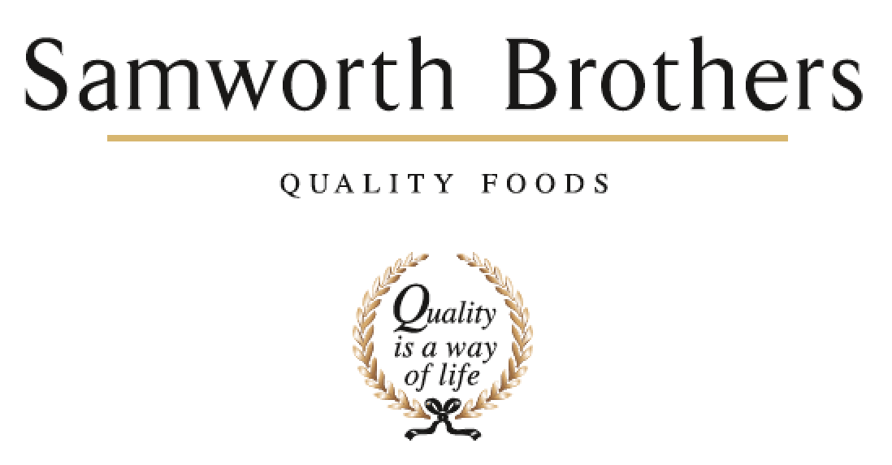

|  |  |  |  |
| --- | --- | --- | --- |
| **ROLE PROFILE** | | | |
| Job title | Hygiene Manager | Date | 10.02.2021 |
| Department | Hygiene | | |
| Location | Soreen | | |
| **ROLE SUMMARY**  Summarise in one or two sentences the highlights of the job in terms of its purpose and overall responsibility. | | | |
| To ensure the hygiene standards are maintained and areas cleaned according to cleaning schedules with all relevant paperwork completed for the jobs. | | | |
| **REPORTING STRUCTURE** | | | |
| Reports to | Operations Manager | | |
| Key internal stakeholders | Operations Director, Technical Manager, Production Manager, HSE Manager | | |
| Key external stakeholders | Chemical Supplier, PPE Consumables, Waste Management Suppliers, Contract Cleaning Company Consumables Supplier | | |
| KEY ACCOUNTABILITIES AND RESPONSIBILITIES | | | |
| **Accountabilities**   * Ensure areas are cleaned according to cleaning schedules in place and to standards required * Complete/check paperwork to ensure all correct to audit standards * Complete actions raised on GMP, Retailer, Third party and Pest Control audits * Ensure all equipment, machinery parts have a written cleaning procedure and are on the cleaning schedule. * Ensure cleaning equipment is clean and suitable for use * Ensure correct colour coding equipment is in use   **Main Duties include:**   * Reporting into the Operations Manager with responsibility for a team of hygiene operatives, covering day & nights shifts. * Develop and manage a robust hygiene team to ensure high standards of cleaning are achieved * Arrange cover for absent staff on hygiene team (to cover sickness and holidays). * Control of departments overheads, to include labour budget, chemical spend and consumables * Ability to work on own initiative (e.g. if areas need cleaning additional to documented schedule * Working closely with production line managers to ensure the site hygiene standards are met and maintained. * Monitoring of the chemical dosing units * Maintain and control stock levels for all cleaning chemicals, cleaning equipment and sundries * Ensure the colour coded cleaning equipment is in the correct designated areas * Ensure cleaning equipment is clean, and suitable for purpose. * Develop and maintain cleaning instructions for the entire site (internal, external, staff facilities etc) * Ensure that the cleaning manual is up to date with all the cleaning tasks documented and recorded. * Carry out training of staff against cleaning schedules and use of cleaning chemicals. * Carry out self audits on equipment to ensure hygiene standards are maintained * Ensuring all areas cleaned according to cleaning schedules in place and to standards required * Complete paperwork for daily, weekly, monthly, 6 monthly & annual schedules – be able to demonstrate this to third party auditors * Ensure Health & Safety is at the fore front of every hygiene activity. All staff must be signed off as competent. * Support all relevant activities in preparation for customer audits and third-party visits * Complete and sign off action points raised in GMP and Pest Control audits. * Complete Risk assessments, SOP’s and SSOW relevant to the hygiene department * Complete a weekly KPI on % cleaning completed. * Any other tasks as and when required as designated by the Operations Manager * Assist with internal audits, to include GMP. * Manage pest control on site, to include the pest control contractor during the site visits * Oversee the Laundry service * Oversee the Waste management system and liaise with Service provider   **KPI’s**   * Manage the hygiene budget in line with the business spend forecast * Ensure all paperwork completed to audit standards * Carry out random checks on equipment to ensure hygiene standards are maintained * Help in the training of staff against cleaning schedules * Ensure cleaning tasks assigned to the Hygiene Staff are carried out * Weekly Hygiene % Compliance to Schedule * Audit Performance – Customer / third party and internal Audits * Hygiene team Absenteeism * Regular 1-2-1’s with staff | | | |
| QUALIFICATIONS, EXPERIENCE, TECHNICAL SKILLS / KNOWLEDGE List the skills gained through education and experience required to effectively function in the position | | | |
| **Essential**   * At least 2 years hygiene experience in a Managerial position in a food manufacturing environment. * Food hygiene for Managers * HACCP awareness * IT proficient with Microsoft Word, Excel, outlook. * COSHH * IOSH * A highly motivated, determined and enthusiastic individual * Excellent communication skills * Ability to influence / negotiate * Ability to build, motivate and lead a team * Decision making / problem solving skills * Ability to work collaboratively, maintaining a positive outlook, under pressure | | | |
| **ATTRIBUTES & BEHAVIOURS FOR SUCCESS** | | | |
| **Behaviour** | **Descriptors** | | |
| **Focused on developing people** | * Consistently demonstrates that people are the top business priority. * Devotes a significant % of time to supporting and coaching their people. * People related activities are consistently placed high on the “to do” list. * Always make themselves available to support team members, regardless of how busy they are. | | |
| **Builds strong relationships** | * Demonstrates they are a good listener who can take on board other points of view. * Demonstrates trust in other teams and other colleagues. * Displays a high level of emotional intelligence to understand how to improve a relationship. * Willing to be the “better person” for the sake of building or maintaining a relationship. * Consciously aware of key relationships which require more work to improve. | | |
| **Courage to make tough decisions** | * Demonstrates they can make a positive decision when none of the alternatives are attractive. * Is able to make quick decisions when needed even if the data is not complete. * Is able to take the “hard / right” decision (which will upset some people) rather than always opting for the “easy / but wrong” decisions. * Consistently demonstrates high standards and does not drop standards just because the implications are challenging. | | |
| **Calmness during challenging times** | * The more challenging the situation the calmer we want our people to be. * Does not get over-emotional when things go wrong. * Recognises that challenging times call for the best kind of leadership. * Focuses on the issue…….not the person who made a mistake or who discovered a problem. | | |
| **Leads by example** | * We should “walk the walk” as well as “talk the talk”. * Displays a consistent approach in how they deal with everyone in the business regardless of their level. * Demonstrates an unshakeable positive attitude regardless of how challenging the circumstances. * Appreciates the views of everyone in the business and welcomes new ideas and challenges. | | |