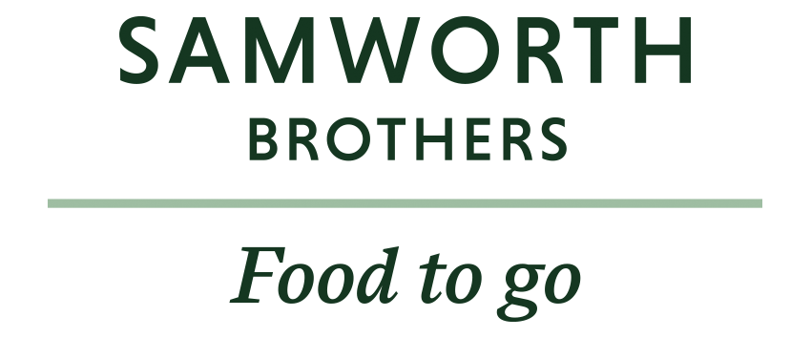

ROLE PROFILE
Job Title | SHE Technician
Business | Melton Foods
Department | SHE Team
Location | Melton Mowbray, Leicestershire
ROLE SUMMARY
At Melton Foods, our people are the heart of our business, and our Safety, Health & Environment Team is at the forefront of ensuring our workplaces are safe, healthy, and compliant.
Supporting the SHE Manager, the SHE Technician will be responsible for ensuring the day-to-day operation of the SHE Management system is functioning correctly.

They will be the first point of contact for the review of incidents, lead and/or support with key site inspections & audits, will coach and guide managers to take personal responsibility for SHE responsibilities within their areas.

The SHE Technician will also undertake SHE improvement projects, as directed by the SHE Manager, ensuring that they are delivered successfully and sustainable. They will also collate key performance metrics, analyse the data and be able to make sound recommendations to drive continuous improvement.

Able to enthusiastically solve problems and the ability to create positive working relationships at all levels, the SHE Technician will be a role model of safety standards and be passionate about keeping our colleagues and our environment, safe and healthy.

REPORTING STRUCTURE
Reports to | SHE Manager
Direct & indirect reports | N/A

SKILLS & ABILITIES
- Work closely with the SHE Manager and the SHE Team to deliver a consistent approach across the site, in line with our SHE Standards and Site SHE Plan.
- Support in the thorough investigation of accidents, near misses and hazards ensuring underlying root causes are identified.
- Carry out key audits and inspections as directed by the audit schedule / SHE Manager.
- Be able to make recommendations to drive continuous improvements following the completion of incident reviews, audits and inspections.
- Ensure action owners are aware of their responsibilities and that they are followed up to ensure completion.
- Support the SHE and People Team with planning and delivering SHE & Wellbeing events.
- Carry out SHE improvements projects as directed by the SHE Manager, including further improvements of the SHE System.
- Work with the Occupational Health and People Teams to ensure health issues are well managed and risks are reduced.
- Support the Managers with Risk Assessments and ensure the Site Risk Register is maintained.
- Work closely with the Site Training Team to ensure 100% compliance of SHE training across site at all levels.
- Be a “critical friend” to managers and supervisors across the site, ensuring they are aware of their SHE responsibilities.

KNOWLEDGE & UNDERSTANDING
- Will have experience and understanding of key hazards associated with the Food & Drinks manufacturing industry, particularly machinery, chemicals, racking and workplace transport.
- A general understanding of regulatory requirements of HSWA, MHSWR, PUWER, COSHH, Fire etc..
- Recognises the importance of taking personally responsible for keeping an up-to-date CPD with a professional body (such as IOSH) and desire to grow within their role.
- Working knowledge of the hierarchy of control through robust risk assessment and a general understanding of the principles of prevention.
- Familiar with contractor control, Permit-To-work processes and able to constructively critique basic RAMS documents.
- Able to work with people of all abilities and backgrounds, to implement change as part of a team.
- Experience in analysing and manipulating data from PowerBI reports and communicating that to the SHE Manager and wider management team were trends are identified.
- Able to prioritise and manage own workload, ensuring deadlines are met and able to escalate where required.
- Aware of own competence and capabilities, knowing when to ask for help and able to learn through experience.
- Understands how to maintain stakeholder relationships and works to support & guide, over do & tell.

QUALIFICATIONS, EXPERIENCE, TECHNICAL SKILLS / KNOWLEDGE
Essential
NEBOSH General Certificate (or equivalent)
Associate or Technical Member of IOSH (or working towards)
Proficient in Microsoft 365 packages

Desirable
NEBOSH Environmental Management Certificate / IEMA Environmental Management Certificate
IEMA Membership
Experience in the Food & Drinks Industry (1-2 years)
Manufacturing / Transport / Warehousing experience
ISO 14001 / 45001 / 9001

CORE COMPETENCIES, ATTRIBUTES & BEHAVIOURS FOR SUCCESS
Competency | Descriptors
Values People | Demonstrates the belief that people are our most important asset and central to the success of the organisation. Everybody should be treated with dignity and respect at all times.
Customer Focus | Is passionate about quality, striving to continuously make a positive difference for our customers and our consumers.
Collaborative  Team Working | The willingness to act as part of a team and work towards achieving shared objectives through adopting best practice in line with our Purpose Statement and Samworth Brothers Values.
Flexibility & Adaptability | The ability to change and adapt own behaviour or work procedures when there is a change in the work environment, for example as a result of changing customer needs.
Initiative &  Taking Ownership | Steps up to take on personal responsibility and accountability for tasks and actions in line with our Purpose Statement and Samworth Brothers Values.
Drive for Excellence | Knows the most effective and efficient processes for getting things done, with a focus on continuous improvement.
Resource Management | Effectively manages resources and cost drivers to achieve sustainable productivity and profitability.
Technical Expertise | Has the skills, knowledge and experience required to excel in own area of specialism and the willingness to further grow and develop.
Self-Management | Uses a combination of feedback and reflection to gain insight into personal strengths and weaknesses, so that own time, priorities, and resources can be managed to achieve goals.

