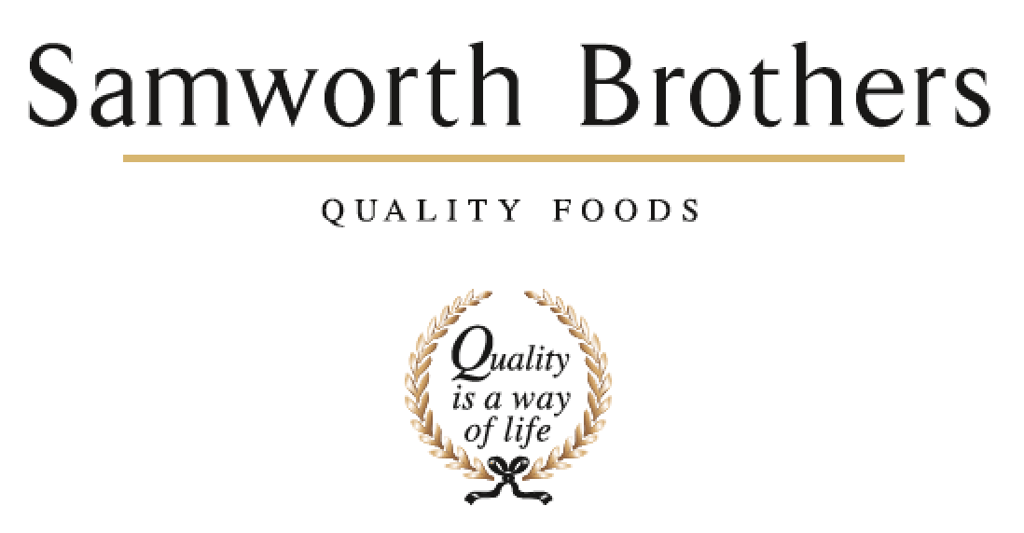

|  |  |  |  |
| --- | --- | --- | --- |
| ROLE PROFILE | | | |
| Job title | Commercial Executive | Date | December 2023 |
| Business | Samworth Brothers Food to Go | | |
| Department | Commercial | | |
| Location | Melton Foods/Bradgate Bakery | | |
| ROLE SUMMARY | | | |
| Food to Go is the biggest category within the Samworth Brother’s portfolio and this role provides the opportunity to gain experience working in a fast-paced dynamic cross-functional business. Reporting into the Senior Commercial Manager, this role will assist in a broad range of sales and commercial administrative tasks, across a wide variety of customers and channels.  This role will enable an enthusiastic Commercial Executive to work as an integral part of the Commercial function, assisting with building of our account plans, product propositions, and customer category strategy. Alongside delivering on the key role responsibilities, the successful candidate will get the opportunity to gain a broad business understanding and work alongside internal stakeholders to aid the development of core commercial skills, supported by our Commercial Excellence programme. | | | |
| REPORTING STRUCTURE | | | |
| Reports to | Senior Commercial Manager | | |
| Direct & indirect reports | N/A | | |
| Key internal stakeholders | Head of Commercial/Senior Commercial Manager/Commercial Manager, Development & Category Teams, Finance, Planning & Operations | | |
| Key external stakeholders | Costa (and New Business as and when applicable) | | |
| KEY ACCOUNTABILITIES AND RESPONSIBILITIES | | | |
| * To assist the Commercial team with the day-to-day administration on their accounts   + Attend weekly meetings to capture key activity and communicate to the wider team   + Action price changes to the business, through product activity forms and ensure price files are accurate and up to date   + Analyse internal data to identify trends, issues and opportunities and communicate them to the commercial team in a timely manner   + Update orders, forecasting, sales, and service trackers to be able to build a view on commercial opportunities and challenges   + Provide support to the Commercial Managers with paperwork required for NPD submissions   + Investigate and report on any service level issues, ensuring updates and solutions are provided in a timely manner | | | |
| * A key point of contact for Supply Chain, Technical, Category and NPD functions * Build a strong rapport with our different customers through effective communication, ensuring Samworth Brothers deliver best in class service * Share best practices across the accounts to create efficient and standardised ways of working, developing reports to measure and communicate performance * Work with Development, Process, Technical and Operations to track the progress of NPD/EPD launches to ensure a smooth customer launch * Attend and support product submission meetings, innovation days and category insight sessions with the customers | | | |
| THE RIGHT PERSON | | | |
| * Passion for food * Good communicator * Strong analytical skills * Strong planning and organisational skills * Problem solver * Innovative thinker, comfortable proposing and implementing their ideas * Hardworking and passionate with an eye for detail and strong can-do attitude. * Relevant degree or equivalent business experience * Experience in an assistant/administrative role is preferred but not essential * A strong working knowledge of Microsoft Office, especially Excel * Full driving licence * Willingness to travel across multiple sites in the Leicestershire area | | | |
| CORE COMPETENCIES, ATTRIBUTES & BEHAVIOURS FOR SUCCESS | | | |
| **Competency** | **Descriptors** | | |
| Values People | Demonstrates the belief that people are our most important asset and central to the success of the organisation. Everybody should be treated with dignity and respect at all times. | | |
| Customer Focus | Is passionate about quality, striving to continuously make a positive  difference for our customers and our consumers. | | |
| Collaborative Team Working | The willingness to act as part of a team and work towards achieving  shared objectives through adopting best practice in line with our purpose  statement and Company values. | | |
| Flexibility & Adaptability | The ability to change and adapt your behaviour or work procedures when  there is a change in the work environment, for example as a result of  changing customer needs. | | |
| Initiative & Taking Ownership | Steps up to take personal responsibility and accountability for tasks in line  with our purpose statement and our Company values. | | |
| Stakeholder Management | The ability to understand people and their motivations, build good relationships with them and help them unlock their potential. | | |
| Commercial Awareness | Demonstrates an understanding of the impact decisions and actions have on the organisation in line with our new purpose statement and Company values. | | |
| Self-Management | Uses a combination of feedback and reflection to gain insight into personal strengths and weaknesses, so that own time, priorities and resources can be managed to achieve goals. | | |
| Technical Expertise | Has the skills, knowledge and experience required to excel inown area of specialism and the willingness to further grow and develop. | | |