 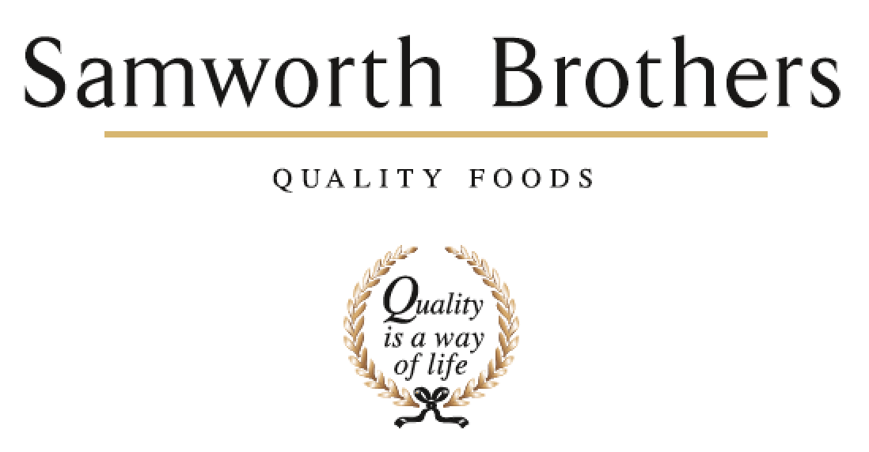

|  |  |  |  |
| --- | --- | --- | --- |
| ROLE PROFILE | | | |
| Job title | Packaging Lead | Date | 23rd June 2024 |
| Department | Marketing | | |
| Location | Trafford Park | | |
| ROLE SUMMARY | | | |
| As the champion of the function, you will set high standards and positively engage all teams to ensure alignment of packaging activities which support annual business plans.  You will work in partnership with our operational teams to ensure packaging is optimised for efficiency and that service is maintained as a priority at all times.  You will also work closely with Samworth Brothers Group Procurement and Responsible Business teams to leverage a Group approach where appropriate. | | | |
| REPORTING STRUCTURE | | | |
| Reports to | **Innovation Lead** | | |
| Key internal stakeholders | **Operations, NPD, Marketing, Senior Leadership team, Supply Chain, Group Procurement** | | |
| Key external stakeholders | **Suppliers, Retailers, Customers** | | |
| KEY ACCOUNTABILITIES AND RESPONSIBILITIES | | | |
| To develop, manage and evaluate all aspects of packaging film and corrugate. This includes:   * Supporting the operational team to resolve film or corrugate issues as required, ensuring the lines are kept running and high service levels are maintained. * Development and execution of packaging innovation and renovation projects, ensuring packaging is optimised from an operational & shopper perspective. * Development and execution of packaging formats and designs, to fit with Marketing and Sales agendas, working closely with Brand Manager, Senior Shopper Marketing Manager & Category Manager. * Ensuring packaging is consistent, protecting brand identity, and updated in line with labelling legislation. * Support in the purchasing and quality monitoring of ongoing packaging materials. * Manage the packaging budget.   **Packaging Innovation**  Project manage Packaging Innovation from concept to launch delivering projects on time, on budget. These will include:   * Working closely with the Operations Team to ensure packaging is optimised for efficiency, product, cost and customer. * Working with Group Procurement and Group Responsible Business team to identify, scope and deliver sustainable and affordable packaging initiatives. * Working with Sales team and Group Procurement to identify new packaging formats to deliver channel strategy whilst meeting all critical path and delivery timescales. * Review and evaluate current packaging designs to ensure continuous improvements/developments.   **Commercial**   * Working with Group Procurement and Finance teams to deliver savings on packaging spend. * Ensuring Packaging Innovation Budget is tracked, updated and all targets met. * Develop and present business cases for packaging innovation projects including costings, timelines and key business benefits, which are approved and tracked post launch. * PIP – identify, implement and deliver packaging profit improvement plans.   **Packaging consistency & quality**   * Responsible for ensuring all packaging formats are consistent across the brand including pack copy and colour standards. Attending press passes where required * Monitoring supplier performance against SLAs * Responsible for ensuring all packaging up to date and in line with current legislation including labelling legislation, UK, EU & FDA requirements * Responsible for final sign off for NPD product packaging with external suppliers to ensure adherence with Brand standards * Development of SRP’s to ensure shoppability, consistency across brand and stand out on shelf * Work closely with Operations Team to ensure packaging is optimised for smooth operational running, efficiency, fit for purpose and consistent quality of output.   **Support the team:**   * Co-ordination, communication, and influence with other departments to educate on the process, strategy, sustainability, performance & importance of Packaging * Support commercial and operational functions to resolve packaging challenges * Providing excellent customer service to all stakeholders at all times (both internal and external) * Complete and supply data packaging data requests including Valpak, Supplier third party, EPR, Packaging Waste Regulations ensuring all deadlines are met. * Attendance at internal meetings with Technical, Operational and Commercial teams as required, e.g morning meeting & pre-launch meetings. * Leveraging innovation from Suppliers, Academia, Innovators etc. in furthering business knowledge * Monitor current and future trends in packaging/packaging manufacturing technology/machinery to ensure business is at the forefront in technology. * Close working with Brand Manager on brand strategy and NPD | | | |
| QUALIFICATIONS, EXPERIENCE, TECHNICAL SKILLS / KNOWLEDGE | | | |
| **Essential**   * Strong knowledge and understanding of key packaging materials i.e. opp film, flexibles, carton-board, corrugated board. * Strong knowledge of print processes (Gravure, flexo, litho) * Proven and relevant Project Management experience * A highly motivated individual who possesses excellent communication and interpersonal skills, able to work with diverse personnel at a variety of levels. * The ability and resilience to thrive in a pressurised environment, prioritising workload to ensure delivery of a professional service to all stakeholders and under tight deadlines. * Be able to complete all tasks to a high standard with strong attention to detail. * Budget management skills * A “can do” attitude and “hands on” approach.   **Desirable**   * Experience in bread or cake bakery packaging expertise and experience of stakeholder management. * Degree qualified or equivalent in a relevant technical discipline | | | |
| CORE COMPETENCIES, ATTRIBUTES & BEHAVIOURS FOR SUCCESS | | | |
| **Competency** | **Descriptors** | | |
| Values People | *Demonstrates the belief that people are our most important asset and central to the success of the organisation. Everybody should be treated with dignity and respect at all times.* | | |
| Customer Focus | *Demonstrates the understanding that the satisfaction of our internal and external customers is the foundation of our success* | | |
| Collaborative Team Working | *The willingness to act as part of a team and work towards achieving shared objectives through adopting best practice in line with PQP and Federalism.* | | |
| Flexibility & Adaptability | *The ability to change and adapt own behaviour or work procedures when there is a change in the work environment, for example as a result of changing customer needs.* | | |
| Initiative & taking ownership | *Steps up to take on personal responsibility and accountability for tasks and actions in line with PQP and Federalism.* | | |
| Drive for Excellence | *Knows the most effective and efficient processes for getting things done, with a focus on continuous improvement.* | | |
| Resource Management | *Effectively manages resources and cost drivers to achieve sustainable productivity and profitability.* | | |
| Technical Expertise | *Has the skills, knowledge and experience required to excel in own area of specialism and the willingness to further grow and develop.* | | |
| Self-Management | *Uses a combination of feedback and reflection to gain insight into personal strengths and weaknesses, so that own time, priorities and resources can be managed to achieve goals.* | | |