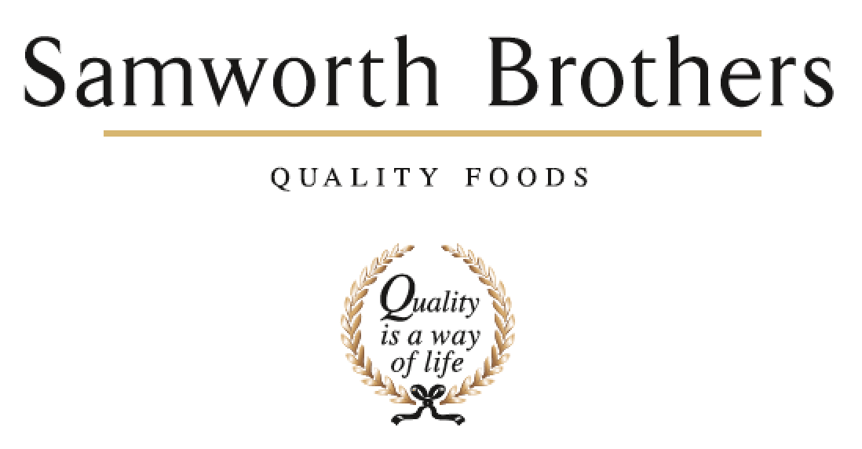

|  |  |  |  |
| --- | --- | --- | --- |
| ROLE PROFILE | | | |
| Job title | Development Chef | Date | May 2024 |
| Business | Savoury Pastry | | |
| Department | Development & Innovation | | |
| Location | The Cornwall Bakery | | |
| ROLE SUMMARY | | | |
| To lead the culinary creation of products for Marks & Spencer, inspiring and challenging to be the best. Delivering of NPD and EPD through Samworth Brothers savoury pastry concept to launch process in line with brand standards & direction from briefs.  Work with the development manager and the cross functional natural working teams to identify and explore new culinary opportunities utilising insight and bringing product to life through internal innovation days & customer submissions of products.  Supporting the NWT with ideation and trend translation into clear product opportunities relevant for savoury pastry. Interpret & Pre-empt customer briefs to ensure new and relevant products are being proposed to our customers.  Maintain up to date and relevant knowledge of products & equipment within the market and capturing trends and quality improvements to enable Samworth Brothers savoury pastry to stay ahead of the competition. | | | |
| REPORTING STRUCTURE | | | |
| Reports to | Development Manager | | |
| Direct & indirect reports | No | | |
| Key internal stakeholders | Development, Technical, Operations, Category & Commercial teams | | |
| Key external stakeholders | Suppliers & Customers | | |
| KEY ACCOUNTABILITIES AND RESPONSIBILITIES | | | |
| 1. Lead the creation of new products from initial concept & ideation through to bakery trial phase, taking commercial (e.g., manufacturing capability, actual cost) constraints into consideration along with consumer and market rationale. 2. Build strong customer relationships arranging and leading product submissions, providing customers with product samples along with relevant paperwork, adhering to brand standards, working with cross functional NWT to create a strong rational for all product proposals. 3. Play an active role within the NWT team ensuring NPD/EPD & innovation requirements meet & align to customer, consumer, and market needs. 4. Proactively maintain awareness of market, consumer and restaurant trends and competitor activity to identify potential business opportunities as well as blue sky and new market trend opportunities. 5. Arrange and lead internal feasibility and critical path meetings for your customers to ensure all key stakeholders have visibility and relevant information on all active projects and products being proposed to the customers. 6. Manage projects and all relevant information on internal recipe management system (Recipe Professor) following and completing all relevant actions ensuring adherence to process. Accurately maintain NPD recipe files and follow Samworth Brothers concept to launch process on all development projects. 7. Act as the key point of contact for your relevant customers, ensuring you respond to any communication in a timely manner and all customers comms are logged & promptly circulated both internally and externally. 8. Build strong relationships with key internal contacts within commercial, category, NPD, technical and operations ensuring strong collaboration and working relationships. 9. Actively look for and present opportunities for new products against consumer and category growth areas, share knowledge and understanding of capabilities within savoury pastry. 10. Build strong relationships with key suppliers leveraging their knowledge and capabilities bringing new relevant ingredients into SB SP whilst maintaining a strong knowledge and understanding of the current raw material list. 11. Work closely with the total development team and innovation team to drive a quality culture and team spirit, to create an environment where people are inspired to perform. | | | |
| QUALIFICATIONS, EXPERIENCE, TECHNICAL SKILLS / KNOWLEDGE | | | |
| * Minimum 5 years’ experience within a chilled food manufacturing environment and ideally experience working with Marks and Spencer * Passion for creating and promoting food at all levels. * 706 1/2, NVQ2/3 or equivalent. * Food Manufacturing culinary experience * Food Hygiene & Allergy training * Numerate Literacy &Computer Skills. * Recipe Formulation understanding and experience. * Food Sensory Skills. * Presentation and Report Writing Skills. * Excellent Communication & Team working skills * Organisation and Time management skills. | | | |
| CORE COMPETENCIES, ATTRIBUTES & BEHAVIOURS FOR SUCCESS | | | |
| **Competency** | **Descriptors** | | |
| Values People | *Demonstrates the belief that people are our most important asset and central to the success of the organisation. Everybody should be treated with dignity and respect at all times.* | | |
| Customer Focus | *Is passionate about quality, striving to continuously make a positive difference for our customers and our consumers.* | | |
| Collaborative Team Working | *The willingness to act as part of a team and work towards achieving shared objectives through adopting best practice in line with our purpose statement and Company values.* | | |
| Flexibility & Adaptability | *The ability to change and adapt your behaviour or work procedures when there is a change in the work environment, for example as a result of changing customer needs.* | | |
| Initiative & taking ownership | *Steps up to take personal responsibility and accountability for tasks in line with our purpose statement and our Company values.* | | |
| People Management | *The ability to understand people and their motivations, build good relationships with them and help them unlock their potential.* | | |
| Empowering others | *Creates an environment where people feel required and enabled to take ownership and responsibility.* | | |
| Coaching for performance | *The ability to help others achieve more through two-way feedback, clear direction and enabling.* | | |
| Analysis & Planning | *The ability to take a range of information, think things through logically and prioritise work to meet commitments aligned with organisational goals.* | | |
| Drive for Excellence | *Knows the most effective and efficient processes for getting things done, with a focus on continuous improvement.* | | |