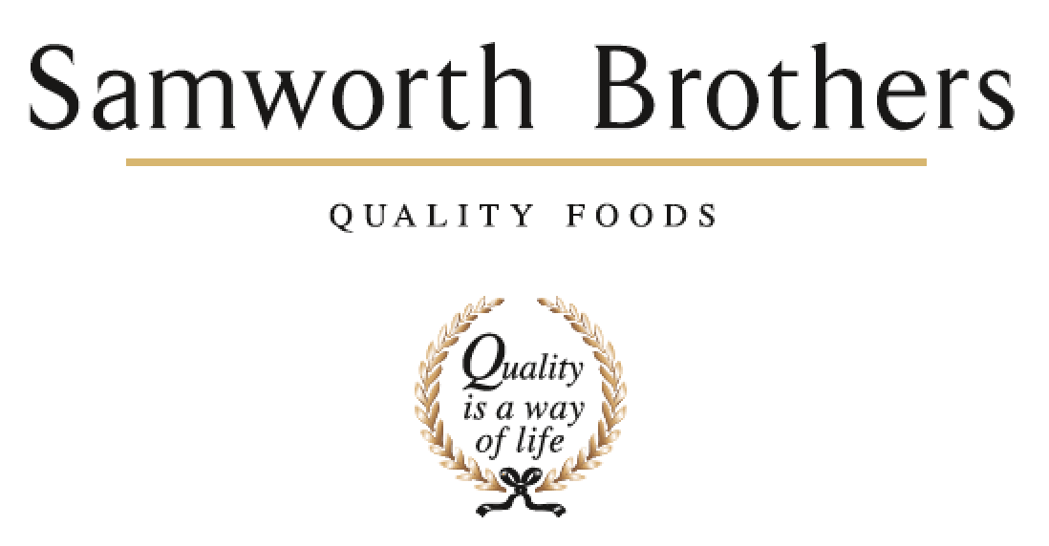

|  |  |  |  |
| --- | --- | --- | --- |
| ROLE PROFILE | | | |
| Job title | Executive Assistant | Date | March 2024 |
| Business | Samworth Brothers Group | | |
| Department | Group Executive Board | | |
| Location | Chetwode House, Melton Mowbray | | |
| ROLE SUMMARY | | | |
| The Executive Assistant (EA)is a varied role that provides high level support to members of the Group Executive Board (GEB). You will be an essential part of the EA team to provide seamless executive level support to the GEB. This diverse role will provide you with a fantastic opportunity to demonstrate your organisational and collaboration skills, providing exceptional service and support at the highest level.  **What the day will look like**   * Your primary responsibility will be providing seamless, executive-level support to the Group Executive Board members that you support. * You will be responsible for the coordination of confidential calendar, inbox and travel management. * You must proactively and proficiently schedule meetings and events and assist as required on high-level projects and varied administrative tasks. * Your role will be to think several steps ahead, anticipating what is needed for the GEB members need to be successful. * As part of a GEB support team of EA support you will work collaboratively as needed to provide support the full team if required | | | |
| REPORTING STRUCTURE | | | |
| Reports to | GEB member | | |
| Direct & indirect reports | None | | |
| Key internal stakeholders | GEB, other EA’s and Chetwode House Team. Family Office, Directors and Senior Leaders across Samworth Brothers Group. | | |
| Key external stakeholders | Customers, Suppliers, Advisors | | |
| SKILLS & ABILITIES | | | |
| * This is a pivotal role that demands exceptional time management and organisational skills, an eye for detail and respect of confidentiality, a proactive and flexible attitude and ability to work autonomously in a stakeholder-dynamic environment. * You will need to have proven exceptional planning and organising skills with the ability to flex your thinking to the short, medium and long term to ensure that there is a seamless execution of activities, deadlines and responsibilities, * Additionally, your ability to quickly build strong professional relationships are crucial in your day-to-day interactions across the business*.* * You will need to be collaborative and demonstrate initiative and drive in order to connect with people across the organisation and externally in a professional, engaging and productive manner | | | |
| QUALIFICATIONS, EXPERIENCE, TECHNICAL SKILLS / KNOWLEDGE | | | |
| **Skills and experience that will lead to success;**   * Ability to maintain a high level of confidentiality is essential. * Proven ability to resolve complex and strategic challenges as they arise. * Previous administration experience in an Assistant or similar role supporting at Board level. * Diary and email management * Slide deck and report preparation. * Travel arrangements * Responsive and ability to move quickly in fast paced environment. * Technologically savvy – experience in using full Microsoft 360 suite (including Teams, One Note and One Drive), video conferencing, etc. * Experience in taking minutes and supporting governance frameworks. * Flexible working environment with commitment to support leader from the office as required. * Experience in supporting someone in a market facing role – i.e. external stakeholder engagement. * Experience of organising events including small conferences | | | |
| CORE COMPETENCIES, ATTRIBUTES & BEHAVIOURS FOR SUCCESS | | | |
| **Competency** | **Descriptors** | | |
| Values People | *Demonstrates the belief that people are our most important asset and central to the success of the organisation. Everybody should be treated with dignity and respect at all times.* | | |
| Customer Focus | *Is passionate about quality, striving to continuously make a positive difference for our customers and our consumers.* | | |
| Collaborative Team Working | *The willingness to act as part of a team and work towards achieving shared objectives through adopting best practice in line with our Purpose Statement and Company Values.* | | |
| Flexibility & Adaptability | *The ability to change and adapt own behaviour or work procedures when there is a change in the work environment, for example as a result of changing customer needs.* | | |
| Initiative & taking ownership | *Steps up to take on personal responsibility and accountability for tasks and actions in line with our Purpose Statement and Company Values.* | | |