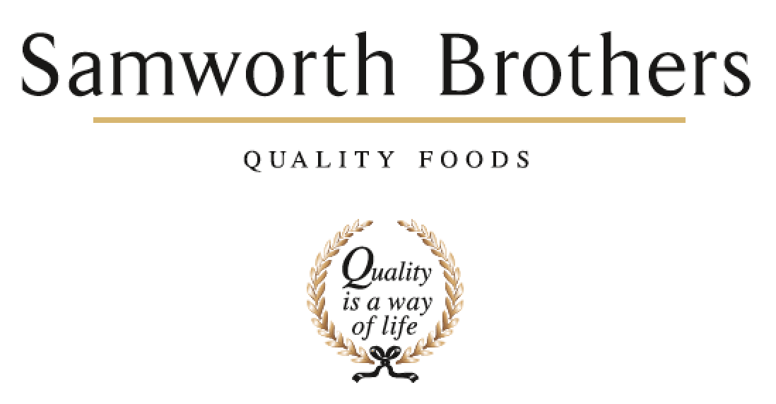

|  |  |  |  |
| --- | --- | --- | --- |
| ROLE PROFILE | | | |
| Job title | Business Improvement Lead | Date | April 2023 |
| Business | Meals | | |
| Department | Business Improvement | | |
| Location | Melton Mowbray | | |
| ROLE SUMMARY | | | |
| You will be responsible for promoting a culture of continuous improvement throughout the business, by encouraging managers and line leaders to actively seek improvements in their own activities and processes. | | | |
| REPORTING STRUCTURE | | | |
| Reports to | Site Director | | |
| Direct reports | BI Assistant, Process Innovation Improvement Manager | | |
| Key internal stakeholders | NPD & Process  Commercial  Production & Engineering  Manufacturing Excellence  Technical  Supply Chain  Finance | | |
| Key external stakeholders | Suppliers  Customers | | |
| KEY ACCOUNTABILITIES AND RESPONSIBILITIES | | | |
| * Lead and drive lean transformation and change initiatives to create and sustain world-class, visually managed manufacturing operations for instantaneous recognition of waste and performance KPI’s in all areas * Implementation of Business System continuous improvement activities in all major lean disciplines and in alignment with strategic initiatives and objectives * Facilitates and/or conducts lean training programs * Manage change whether in new equipment , processes , or raw materials to ensure food safety, quality and legality, efficiencies and yields are not compromised * Organise and manage CI workloads to ensure that their projects are achievable and are on track to completed * Work with Manufacturing excellence teams to deliver best practice efficiency solutions * To ensure that effective, planning, organisation and communication is in place internally for the effective adherence to the critical path and successful implementation of processes into the business. * To ensure that all teams are educated, upskilled and the appropriate training has been deployed and results are measurable. * To be proactive in developing the business going forward through innovation and creativity, initiating new processes and product improvements to drive quality and efficiency. * To be known as a subject matter expert to advise and assist in the efficient development of manufacturing processes | | | |
| QUALIFICATIONS, EXPERIENCE, TECHNICAL SKILLS / KNOWLEDGE | | | |
| * Demonstrated ability to influence site leadership   + Coaching of others in CI thinking & application   + Clear verbal and visual communicator * Ability to work effectively with Bakery colleagues   + Bakery operatives through to leadership team   + Ability to flex style to the team being worked with (situational leadership) * Experience of manufacturing (not necessarily Food, but must be manufacturing operations experience i.e. not banking)   + Material & labour mgmt.   + Maintenance / engineering / change-over   + Production   + Planning * Solid knowledge and application of “Lean” basics   + Workplace organisation & Lean “waste”   + Operations & Engineering Standard work   + Leaders standard work   + Visualisation of balanced scorecard KPI data & tiered performance of KPIs / performance   + Visual standards * Expert problem solver with demonstrated capability of using structured problem solving to solve complex issues   + Ability to train & coach structured problem solving at all levels     - DMAIC     - A3 / Practical Problem Solving approach     - Numeracy / ability to work with large data sets     - Black Belt certified, GB trained as a minimum       * Ability to train & coach GB / BB capability build * Lead creation and deploy of annual ManEx roadmap plan   + Able to lead CI maturity assessment and prioritise capability build into ManEx deployment roadmap * Structured approach to CI / PIP project execution   + CI Program governance   + Strong capabilities in Project and Change mgmt. techniques | | | |
| CORE COMPETENCIES, ATTRIBUTES & BEHAVIOURS FOR SUCCESS | | | |
| **Competency** | **Descriptors** | | |
| Values People | *Demonstrates the belief that people are our most important asset and central to the success of the organisation. Everybody should be treated with dignity and respect at all times.* | | |
| Customer Focus | *Demonstrates the understanding that the satisfaction of our internal and external customers is the foundation of our success* | | |
| Collaborative Team Working | *The willingness to act as part of a team and work towards achieving shared objectives through adopting best practice in line with PQP and Federalism.* | | |
| Flexibility & Adaptability | *The ability to change and adapt own behaviour or work procedures when there is a change in the work environment, for example as a result of changing customer needs.* | | |
| Initiative & taking ownership | *Steps up to take on personal responsibility and accountability for tasks and actions in line with PQP and Federalism.* | | |
| People Management | *The ability to understand people and their motivations, build good relationships with them and help them unlock their potential.* | | |
| Empowering others | *Creates an environment where people feel required and enabled to take ownership and responsibility.* | | |
| Coaching for performance | *The ability to help others achieve more through two-way feedback, clear direction and enabling.* | | |
| Analysis & Planning | *The ability to take a range of information, think things through logically and prioritise work to meet commitments aligned with organisational goals.* | | |
| Drive for Excellence | *Knows the most effective and efficient processes for getting things done, with a focus on continuous improvement.* | | |