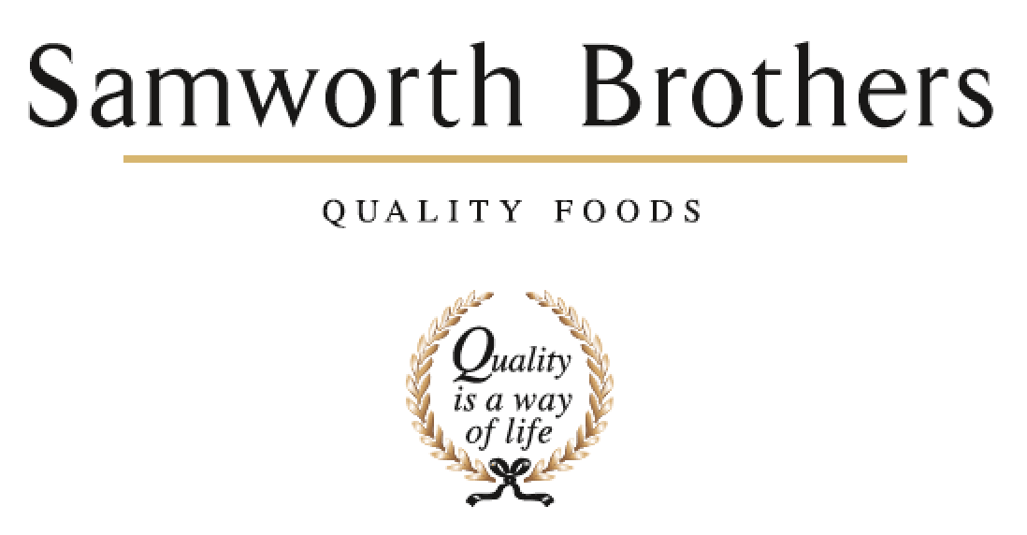

|  |  |  |  |
| --- | --- | --- | --- |
| ROLE PROFILE | | | |
| Job title | Quality Manager – Lynher bakery | Date | August 2024 |
| Business | The Cornwall Bakery | | |
| Department | Technical | | |
| Location | Callington | | |
| ROLE SUMMARY | | | |
| Responsibility for ensuring the food safety, quality and compliance of all products including the application and implementation of all relevant food safety and quality systems. Ensuring compliance to site standards and leading the Quality agenda. Lead, coach and actively support the QA and Operational teams to deliver the bakeries objectives. | | | |
| REPORTING STRUCTURE | | | |
| Reports to | Technical Manager – Lynher | | |
| Direct & indirect reports | Direct: Shift QA | | |
| Key internal stakeholders | Operational Managers, Operations Teams, Technical Department, Hygiene | | |
| Key external stakeholders | Customers / Brand Team | | |
| KEY ACCOUNTABILITIES AND RESPONSIBILITIES | | | |
| 1. To manage the QA Team, to ensure department runs efficiently and effectively, setting the standard for the team and monitoring performance through KPI’s. 2. Drive improvements in GMP, Food Safety and product Quality, ensuring audit ready at all times. Assist with customer visits and subsequent liaison to ensure action points are dealt with promptly. 3. Arrange, document and monitor all validation work required; CCP validation, WIP life, permitted extensions, Pre-requisite validation, Allergens and new equipment validation. 4. Plan and execute training for QA staff to enable them to perform their duties effectively in a continuous improvement environment, ensuring all QA’s are trained and signed off against policies, and conduct PDM’s for each QA. 5. Manage and audit compliance to Automatic packaging verification customer requirements. 6. Bakery responsible Manager for Quality & taste panels. Ensure correct attendance, monitor and trend results, escalating issues as required. 7. Develop and manage the bakery complaint reduction plan in conjunction with the QSM and Bakery Managers. 8. Oversee projects and propose any changes that are required to enhance both department and the company. 9. To ensure non-conformances and corrective actions in the Bakery are investigated and reviewed. 10. Ensure QA attendance at the daily operations meetings, to feedback technical issues and be aware of bakery performance. 11. Provide the relevant input on quality issues as and when required, to the customer and Operations. 12. Ensure that all procedures are adhered to in the factory by all departments and that the paperwork is completed correctly to provide site due diligence. 13. Assess the effectiveness of the sites daily / weekly audits and ensure that all non conformances are closed out. 14. Provide support to the Technical Management Team as required. Role would incorporate a weekend on call rota (Currently once every 7 weeks). Deputise for bakery Technical Manager and provide cover for Tamar bakery QM as required. 15. Drive technical standards with the manufacturing environment and ensure audit standards are met at all times. 16. Decide upon and clearly communicate the corrective actions required from daily microbiological exception reports for finished product micro and water analysis.   Monitor and trend results   1. Support Heath and Safety initiatives as required. | | | |
| QUALIFICATIONS, EXPERIENCE, TECHNICAL SKILLS / KNOWLEDGE | | | |
| * Significant experience in quality/technical management roles in fast paced, chilled, food manufacturing environments. * Technical knowledge and expertise within chilled food. * A good technical knowledge of supermarkets food safety requirements plus a working knowledge of their IT systems. * Experience of customer and industry audits * HACCP Level 3 * Food Safety Level3 * Proven skills in developing and leading teams * Proven skills in coaching and mentoring * Excellent verbal and written communication skills * Strong influencing skills * The ability to deliver a compelling vision for technical quality at all levels both internally and externally * Excellent knowledge of MS Office – Word / Excel / PowerPoint. * Strong communication and interpersonal skills including both written and verbal communication * Flexible approach | | | |
| CORE COMPETENCIES, ATTRIBUTES & BEHAVIOURS FOR SUCCESS | | | |
| **Competency** | **Descriptors** | | |
| Values People | *Demonstrates the belief that people are our most important asset and central to the success of the organisation. Everybody should be treated with dignity and respect at all times.* | | |
| Customer Focus | *Demonstrates the understanding that the satisfaction of our internal and external customers is the foundation of our success* | | |
| Collaborative Team Working | *The willingness to act as part of a team and work towards achieving shared objectives through adopting best practice in line with PQP and Federalism.* | | |
| Flexibility & Adaptability | *The ability to change and adapt own behaviour or work procedures when there is a change in the work environment, for example as a result of changing customer needs.* | | |
| Initiative & taking ownership | *Steps up to take on personal responsibility and accountability for tasks and actions in line with PQP and Federalism.* | | |
| People Management | *The ability to understand people and their motivations, build good relationships with them and help them unlock their potential.* | | |
| Empowering others | *Creates an environment where people feel required and enabled to take ownership and responsibility.* | | |
| Coaching for performance | *The ability to help others achieve more through two-way feedback, clear direction and enabling.* | | |
| Analysis & Planning | *The ability to take a range of information, think things through logically and prioritise work to meet commitments aligned with organisational goals.* | | |
| Drive for Excellence | *Knows the most effective and efficient processes for getting things done, with a focus on continuous improvement.* | | |