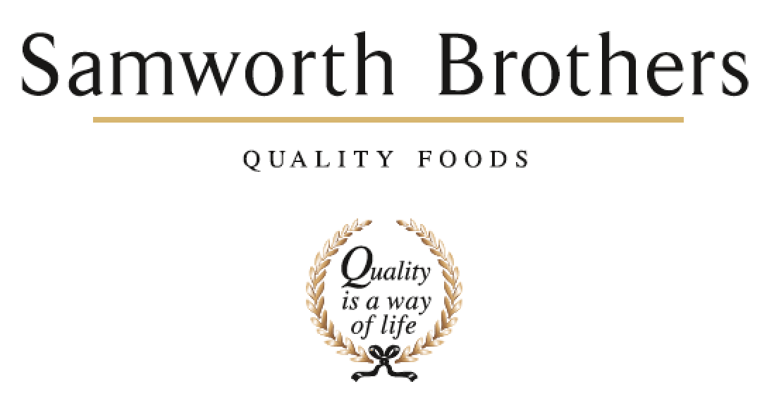

ROLE PROFILE
Job title | Site Hygiene Manager | Date | January 2026
Business | Walkers Deli & Sausage Co.
Department | Hygiene
Location | 78-88 Cobden Street, Cobden Industrial Estate, Leicester, LE1 2LB
ROLE SUMMARY/PURPOSE OF THE ROLE
The site Hygiene manager is responsible for ensuring that the entire food manufacturing facility meets and maintains the highest standards of hygiene and food safety. This includes managing cleaning operations, hygiene systems, hygiene teams, and compliance with legal, customer and certification requirements 24 hrs a day 7 days a week.

The role supports food safety, audit readiness and operational efficiency
REPORTING STRUCTURE
Reports to | Site
Direct & indirect reports | Hygiene Area Managers, Hygiene Team Leaders and Hygiene Operatives
Key internal stakeholders | Operations, Technical and Engineering
Key external stakeholders | Hygiene suppliers; Pest Control; Environmental systems, waste management

KEY ACCOUNTABILITIES AND RESPONSIBILITIES
- Lead and manage the hygiene team to maintain and improve hygiene standards across the site covering 3 factories with both High risk and low risk facilities

- Develop, implement, and monitor daily and deep cleaning schedules, SOPs, CICs, RAs for all production and peripheral areas.

- Ensure compliance with food safety legislation, company policies, and audit requirements (HACCP, BRC, GMP).

- Monitor and manage cleaning effectiveness, Validate and verify cleaning methods and hygiene procedures to ensure effectiveness and a safe consistent successful repeatable cleans have been achieved

- Ensure consistently audit ready conditions for internal, customer and third-party audits

- Conduct hygiene risk assessments and implement corrective actions where necessary.

- Investigate and report hygiene-related non-compliances, taking appropriate action to protect the business.

- Maintain accurate hygiene documentation and records for audits and inspections.

- Drive continuous improvement initiatives to enhance hygiene processes and reduce contamination risks.

- Contribute to product process design from hygiene perspective and hygiene design

- Collaborate with production, technical, quality assurance, and maintenance teams to support operational efficiency.

- Manage departmental KPIs and ensure alignment with business objectives.

- Recruit, train, and develop hygiene team members to build capability and engagement.

- Control hygiene-related budgets and manage resources (labour, equipment, contractors) effectively.

- Ensure safe use and storage of cleaning chemicals in line with COSHH regulations.

- Prepare for and support internal and external audits related to hygiene and food safety.

- To ensure business hygiene standards are maintained, risk assessed and reviewed, striving for best practice at all times.

- Ensure all hygiene tasks are carried out within the Health & Safety requirements

- To ensure the data input for management operating systems for all areas are accurately maintained to enable responsive fact-based management of the operation.

- To ensure that all aspects of hygiene operations are adequately resourced and rostered with the correct skill levels.

- To develop a highly motivated team developing skills to support continuous improvement in hygiene.

- To deliver on Key Performance Indicators.

QUALIFICATIONS, EXPERIENCE, TECHNICAL SKILLS / KNOWLEDGE
- Previous experience of hygiene or technical operations within food manufacturing operations, incl HACPP, BRC, GMP
- Proven Leadership and Team Management experience
- Proven track record in cost control, health & safety and management of quality systems
- Ability to interact with high profile customers
- Excellent communication and problem-solving skills
- Experience in managing audits and compliance processes
- Advanced Food Hygiene
- HACCP Level 3

CORE COMPETENCIES, ATTRIBUTES & BEHAVIOURS FOR SUCCESS
Competency | Descriptors
Values People | Demonstrates the belief that people are our most important asset and central to the success of the organisation. Everybody should be treated with dignity and respect at all times.
Customer Focus | Demonstrates the understanding that the satisfaction of our internal and external customers is the foundation of our success
Collaborative Team Working | The willingness to act as part of a team and work towards achieving shared objectives through adopting best practice in line with PQP and Federalism.
Flexibility & Adaptability | The ability to change and adapt own behaviour or work procedures when there is a change in the work environment, for example as a result of changing customer needs.
Initiative & taking ownership | Steps up to take on personal responsibility and accountability for tasks and actions in line with PQP and Federalism.
People Management | The ability to understand people and their motivations, build good relationships with them and help them unlock their potential.
Empowering others | Creates an environment where people feel required and enabled to take ownership and responsibility.
Coaching for performance | The ability to help others achieve more through two-way feedback, clear direction and enabling.
Analysis & Planning | The ability to take a range of information, think things through logically and prioritise work to meet commitments aligned with organisational goals.
Drive for Excellence | Knows the most effective and efficient processes for getting things done, with a focus on continuous improvement.

