- Role Description

Job Title: | Engineer
Location: | Saladworks
Division: | Meals

Role Definition: (Summarise the purpose of the role and the contribution this job makes to the organisation’s purpose – what is it here to deliver).
To react to the sites engineering day-to-day operations ensuring systems are applied to deliver a safe, efficient and effective response to site activities. To ensuring effective communication to Team Leader, and reporting is carried out.
Support the Maintenance Manager by improving site performance through route cause analysis and MBR’s (Machine Breakdown Records).
Ensure adherence to PPM’s is maintained at all times.

Reporting Relationships: (Insert an organisational chart showing where this job sits and the jobs immediately around it).
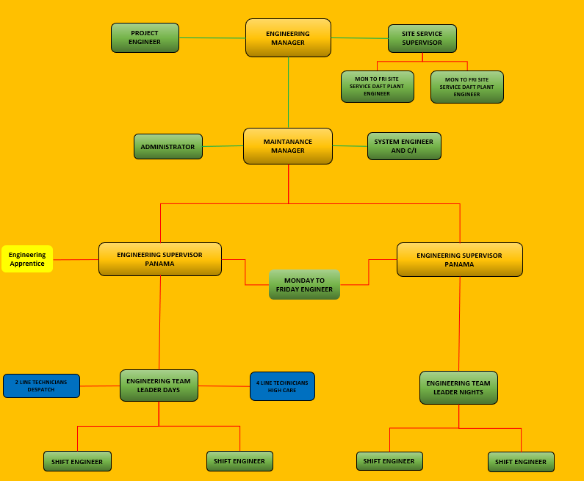

Budget Responsibility: (Summarise any budgetary controls / key numerical or financial facts and figures that are relevant to the job).
To ensure cost effective and value for money repairs and procedures are carried out

Accountabilities: ( 6 to 8 statements identifying the principal outputs required of the job in order to deliver its purpose).
Control and maintain required standards of the following:

- Health and Safety.
- Absence.
- Housekeeping.
- Hygiene.
- Conduct.
- Statutory regulations.
- Codes of practice.
- To effectively manage outside contractors and services.
- To provide support and advice to engineers and operational team where appropriate.
- To manage own workload with team leader and to check Issues log for daily tasks.
- Completion of the shift hand - over breakdown board and reports to ensure effective hand over.
- To ensure completion and accuracy of Plant Maintenance, escalate reasons which would not allow completion
- Enforce Good Manufacturing Practice (GMP), within factory areas.
- Proactively support the Tier process and meetings.

Ensure required service/performance levels are achieved in respect of the following:

- Rapid response to breakdown situations.
- Correct and timely diagnosis of faults.
- First time fixes and follow up.

Identify improvement areas within the line engineering processes and recommend solutions. Make recommendations on Operator/Engineering interface to determine best practices which will deliver required performances in the following:

- Remove barriers between functions.
- Clearly define roles and accountabilities at the interface.
- Identify overlaps in activities and address improvements.

Report on line issues/performances as required by the engineering Manager in respect of frequency, format, data etc.

Competency Requirements: (Delete tick where competency doesn’t apply).
Values required from team: | Honesty, Passion, Determination, high standards.
Resilience | Never gives up. Relentless, proactive focus on reducing HS risks. Meet or exceeds targets without being asked.
Brilliant Execution | Use thinking skills to analyse, decide, prioritise and plan. Can balance short term requirements with long term objectives to achieve goals.
Communication and Influencing Skills | Able to influence people at all levels, internal and external, through listening and adjusting communication style to meet the needs of the audience.
Customer Focused | Understands the customer better than anyone else in the business. Always seeking to improve quality and service for our internal / external stakeholders.
Team Player | Works with colleagues to do what is best for the Company as a whole, ahead of divisional, department or personal goals.
Leadership | Puts the team first. Owns results of self and team. Inspires others to follow through involvement, coaching, setting direction and performance standards.
Knowledge / Skills / Qualifications: (What skills, qualifications and experience are necessary for FULL and EFFECTIVE performance?)

Relevant qualification in Mechanical/Electrical engineering
Strong planning and organising ability (of own workload and that of others).
Ability to prioritise and work effectively under pressure. Financial awareness. Highly developed communication skills (verbal, written, listening, influencing). Excellent coaching and training skills.
Strong leadership ability.
Self motivated and proactive approach to work.
Awareness of Health and Safety and other relevant legislation
Ability to communicate to all levels within the business
Must be able to work on their own and in a team environment
Ability to develop and manage a team of engineers

Competencies

Takes ownership of work delegated and communicates issues/ work completed back to team leader. These should also be recorded onto the issues log.
Any Health & Safety concerns must be reported to Team Leader immediately.

