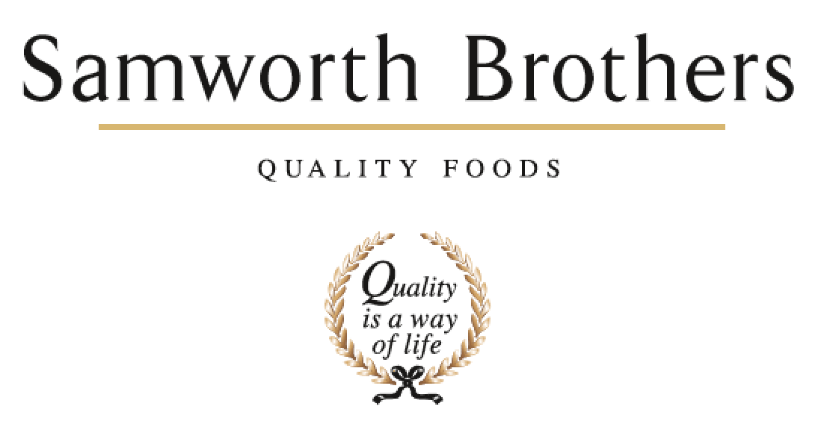

ROLE PROFILE
Job title | Shift Manager | Date | December 2025
Business | Walker and Son
Department | Hygiene
Location | Walker and Son
ROLE SUMMARY
Managing / coaching a hygiene team whose focus is food safety, Health & safety and to maintain and improve the hygiene standards within the bakery. Ensuring production and all peripheral areas of the Bakery are cleaned to an exceptionally high standard to meet all technical requirements.

REPORTING STRUCTURE
Reports to | Site Hygiene Manager
Direct & indirect reports | Team Leader, Operatives
Key internal stakeholders | Engineering, Planning, Technical, Jelly, Despatch, Health & Safety, Commercial, CI
Key external stakeholders | Customers & Audits

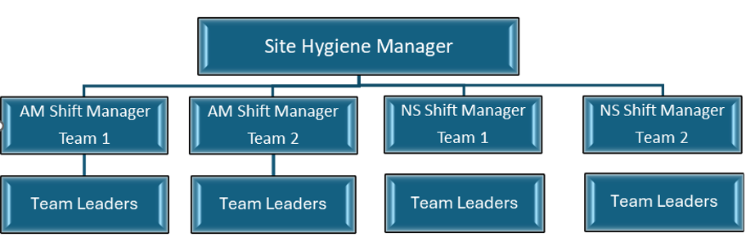

KEY ACCOUNTABILITIES AND RESPONSIBILITIES
- Management and achievement of KPI’s, in relation to hygiene efficiencies, microbiological, customer service, cost control, people, quality and health and safety through a continuous improvement approach
- Ensure continuous compliance with food safety, health and safety, quality and Good Manufacturing Practice (GMP) standards
- Co-ordination of permanent and temporary labour during shift
- Undertake and lead key business projects to drive continuous improvement
- Liaise with all other areas of the business to ensure successful achievement of manufacturing targets
- Keep shift data updated and ensure effective handover to appropriate colleagues coming onto shift
- To recruit, induct and develop employees to a competent level to be effective hygiene team members
- Develop and maintain a strong working relationship with all departments to drive continuous improvement in site standards
- To ensure all aspects of the hygiene services are carried out and maintained to the highest of standards
- To ensure daily deep cleans are completed in line with CIC’s and site expectations
- Responsibility for managing people policies to ensure compliance e.g. disciplinary, grievance, flexible working requests
- To support the technical department and take responsibility for actions in microbiological investigations
- To drive cost savings in hygiene and waste overheads to ensure annual forecasts are achieved
Health & Safety
- To have a proactive approach to Health & Safety and lead by example
- Enhance the Health & Safety culture through staff involvement
- Embed safety measures across all hygiene and waste handling activities to reduce accidents
- To ensure the safe use of chemicals at all times in line with CIC’s and manufacturer recommendations

Waste and Environmental
- To ensure waste segregation to meet the site environmental KPI’s
- To ensure the external yard and waste areas are maintained in a safe, controlled and hygienic manner at all times.

People
- Manage, train and develop Team Leaders and their teams to ensure optimum effectiveness and efficiency and identify and address any skills gaps
- Ensure effective lines of communication are in place between the management team and team leaders and operatives
- To conduct regular performance development reviews with your Team Leaders and establish training and develop plans
- Conduct Personal Development meetings with Team Leaders
- Liaise with Personnel on staffing issues and requirements

QUALIFICATIONS, EXPERIENCE, TECHNICAL SKILLS / KNOWLEDGE
Qualifications / Experience

- Minimum Two years hygiene management experience within a food manufacturing environment
- Previous experience of working with a large diverse workforce.
- Good level of English & maths (must be numerate)
- Educated to GCSE / ‘A’ Level
- Intermediate/Advanced (L3 / L4) Food Hygiene Certificate
- NVQ Level III or above
Knowledge / Technical Skills

- A strong hygiene background within an FMCG environment
- High level of competence in Root Cause Analysis
- Customer facing experience with well-developed communication skills.
- Resilient and flexible with the ability to adapt to changing priorities, demands and timelines.
- Demonstrate an understanding of the principles of Continuous Improvement (CI) uses appropriate tools and techniques
- Has an awareness of financial implications of decision / actions
- Demonstrates an understanding of exactly what drives cost within your area
- Demonstrates an understanding of how to manage people
- Demonstrates an understanding of how to manage processes
- Demonstrates an understanding of how to manage projects
- Demonstrates an understanding of how to manage resources
- Demonstrates an understanding of your own responsibilities as a manager to health, safety and environment as per company policy and carry out the company Safe Operating Practices (SOPs) and procedures
- Demonstrates an understanding of how to use appropriate ICT programmes
CORE COMPETENCIES, ATTRIBUTES & BEHAVIOURS FOR SUCCESS
Competency | Descriptors
Values People | Demonstrates the belief that people are our most important asset and central to the success of the organisation. Everybody should be treated with dignity and respect at all times.
Customer Focus | Demonstrates the understanding that the satisfaction of our internal and external customers is the foundation of our success
Collaborative Team Working | The willingness to act as part of a team and work towards achieving shared objectives through adopting best practice in line with PQP and Federalism.
Flexibility & Adaptability | The ability to change and adapt own behaviour or work procedures when there is a change in the work environment, for example as a result of changing customer needs.
Initiative & taking ownership | Steps up to take on personal responsibility and accountability for tasks and actions in line with PQP and Federalism.
Attributes & Behaviours | - Accept responsibility for work of self and others  - Adopt a collaborative approach, wanting to work well with internal colleagues at all levels  - Adopt a professional approach to work and maintain confidentiality  - Adopt on-going commitment to quality, safety and hygiene standards, and never turns a blind eye  - Adopt a flexible approach to business requirements  - Willing to listen and consider the views of others  - Demonstrates the ability to think ahead to prioritise tasks  - Demonstrate you are tasks orientated and focused on objectives  - Demonstrating you are willing and able to accept and adapt to change; including changing demands or objectives, willing to turn your hand to anything and never says, “That’s not my job”  - Adopt an organised approach to work  - Treat people as equals and generate a rapport build on trust and honesty

