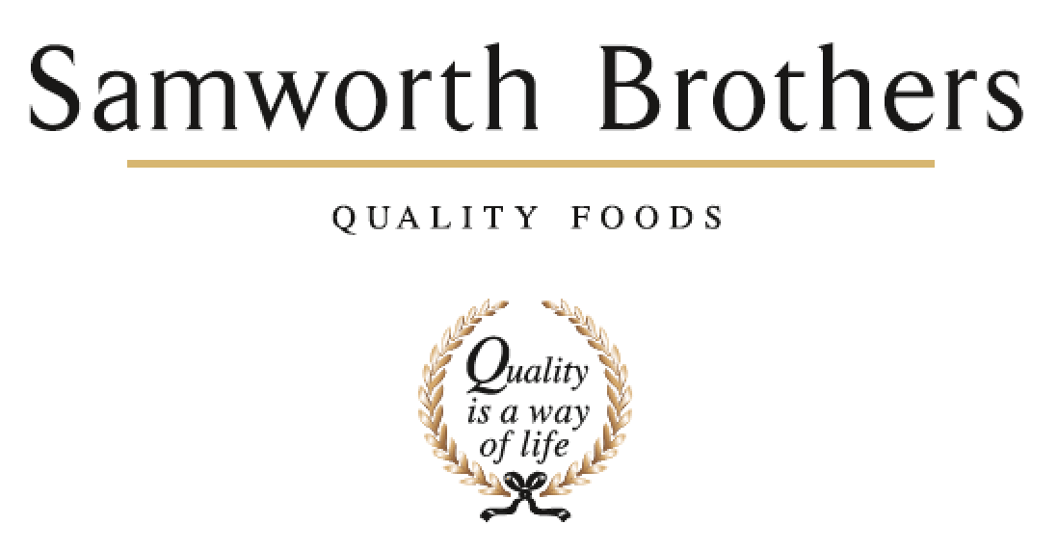

ROLE PROFILE
Job title | Maintenance Manager | Date | June 2025
Department | Engineering
Location | Soreen
ROLE SUMMARY
Summarise in one or two sentences the highlights of the job in terms of its purpose and overall responsibility.
Responsible for managing a team of Multi Skilled Maintenance Technicians and the day to day running of the maintenance department with Safety, People, Quality, Service and cost control at the forefront.
Develop a culture of positive, proactive ways of working.
REPORTING STRUCTURE
Reports to | Manufacturing Manager
Direct reports | Engineers
Key internal stakeholders | Board team, Operational Management, Engineers, Operatives, Technical, Hygiene, People team.
Key external stakeholders | Suppliers and Contractors.

KEY ACCOUNTABILITIES AND RESPONSIBILITIES
- To manage and develop the team of Engineers safely and effectively. Ensuring team members have 121s and Time with your manager conversations. Development through on the job coaching and identifying training needs.
- Improving safety, performance and quality of Soreen’s production by continually improving the engineering function and operational performance. Ensuring cost effective, efficient and effective maintenance work is carried out
- To manage external contractors and ensure they work safely and within required guidelines
- Assist in managing the engineering budget where you will feedback on a weekly and monthly basis engineering spend.
- In conjunction with the HSE Manager, you will effectively manage all site and legislative requirements for equipment, pressure systems, lifting equipment etc.
- Working cross functionally to ensure maximum availability of assets. You will be required to provide detailed reports on asset performance.
- Proactively develop and lead in implementing an effective preventative maintenance strategy, monitoring and controlling all engineering work, ensuring all work is completed to the highest standard, adhering to legal requirements and quality systems in place.
- To deliver the PPM system to ensure all machinery is maintained, runs effectively and has maximum availability.
- Control stock holding of spares, identify spares to be held and manage usage. Manage stock reduction plan.
- Build successful cross functional relationships to ensure that the engineering function works positively & effectively with Operations.
- Ensure that maintenance colleagues skill requirements are maintained in line with technological improvements and are aligned to the asset base.
- Play a key role in developing capital investment plans & work with the bakery leadership team to ensure that capital investment improvements are delivered to agreed timescales.
- Ensure the production plan is achieved daily.
- Ensure the target of OEE of all plant is achieved at all times
- Ensure all statutory and company system requirements are always met, including Safety, HACCP and BRC.
- Manage engineering labour resources effectively and within budget
- Out of hours/on call working to meet the business needs.

QUALIFICATIONS, EXPERIENCE, TECHNICAL SKILLS / KNOWLEDGE
List the skills gained through education and experience required to effectively function in the position
Essential
- A proactive approach
- Ability to analyze and solve problems methodically
- Able to build relationships across all factory functions as part of a team
- Drive to improve, learn and succeed
- Open to change
- Practical experience gained within engineering function within FMCG environment
- Positive and strong influencing skills at all levels
- Strategic/tactical awareness
- Critical thinking and root cause analysis

ATTRIBUTES & BEHAVIOURS FOR SUCCESS
Behaviour | Descriptors
Focused on developing people | - Consistently demonstrates that people are the top business priority.  - Devotes a significant % of time to supporting and coaching their people.  - People related activities are consistently placed high on the “to do” list.  - Always make themselves available to support team members, regardless of how busy they are.
Builds strong relationships | - Demonstrates they are a good listener who can take on board other points of view.  - Demonstrates trust in other teams and other colleagues.  - Displays a high level of emotional intelligence to understand how to improve a relationship.  - Willing to be the “better person” for the sake of building or maintaining a relationship.  - Consciously aware of key relationships which require more work to improve.
Courage to make tough decisions | - Demonstrates they can make a positive decision when none of the alternatives are attractive.  - Is able to make quick decisions when needed even if the data is not complete.  - Is able to take the “hard / right” decision (which will upset some people) rather than always opting for the “easy / but wrong” decisions.  - Consistently demonstrates high standards and does not drop standards just because the implications are challenging.
Calmness during challenging times | - The more challenging the situation the calmer we want our people to be.  - Does not get over-emotional when things go wrong.  - Recognises that challenging times call for the best kind of leadership.  - Focuses on the issue…….not the person who made a mistake or who discovered a problem.
Leads by example | - We should “walk the walk” as well as “talk the talk”.  - Displays a consistent approach in how they deal with everyone in the business regardless of their level.  - Demonstrates an unshakeable positive attitude regardless of how challenging the circumstances.  - Appreciates the views of everyone in the business and welcomes new ideas and challenges.

