- Role Description

Job Title: | Site Services Engineer
Location: | Saladworks
Division: | Meals

Role Definition:
To maintain the sites services, ensuring supplies are delivered safely and efficiently to meet the sites requirements. Effectively communicate to the site services team and other departments of any issues or risks. Carry out scheduled checks and servicing to maintain sites systems.
Support the Site Services Team Leader by improving site performance using route cause analysis and MBR’s (Machine Breakdown Records).
Ensure adherence to PPMs is always maintained and report any remedial work or finding to the engineering management team.
Record all work and checks on the Computerised Maintenance Management System.
Ensure all items of equipment which fall under legislative compliance are maintained and certificated in line with HSE guidelines.

Reporting Relationships:
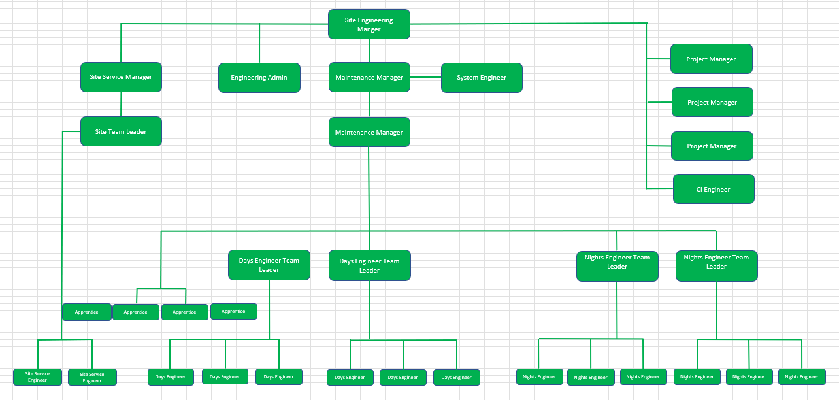

Budget Responsibility:
Ensure maintenance and checks are carried out in-line with budget and escalate any additional requirements that are unbudgeted to engineering management.

Accountabilities: ( 6 to 8 statements identifying the principal outputs required of the job in order to deliver its purpose).
Control, improve and maintain the following standards:

- Health, Safety and environmental.
- Housekeeping.
- Hygiene.
- Conduct.
- Codes of practice.
- Control and manage outside contractors and services.
- Good time management.
- Completion of the shift handover.
- Record all activities on the CMMS.
- Completion of plant maintenance and checks.
- Good Manufacturing Practice (GMP).
- Proactively support the Tier meeting structure.

Ensure required service/performance levels are achieved in respect of the following:

- Rapid response to breakdown situations.
- Correct and timely diagnosis of faults.
- First time fixes and follow up.

Identify areas of improvement within the site services processes and recommend solutions.

- Communicate effectively with all departments necessary.
- Identify nonvalue added tasks and recommend improvements.
- Provide recommendations to improve sites GMP.

Report issues, breakdowns and risks to the site services team leader.
Competency Requirements:
Values required from team: | Honesty, Passion, Determination, high standards. |  | 
Resilience | Never gives up. Relentless, proactive focus on reducing HS risks. Meet or exceeds targets without being asked.
Brilliant Execution | Use thinking skills to analyse, decide, prioritise and plan. Can balance short term requirements with long term objectives to achieve goals.
Communication and Influencing Skills | Able to influence people at all levels, internal and external, through listening and adjusting communication style to meet the needs of the audience.
Customer Focused | Understands the customer better than anyone else in the business. Always seeking to improve quality and service for our internal / external stakeholders.
Team Player | Works with colleagues to do what is best for the Company as a whole, ahead of divisional, department or personal goals.
Knowledge / Skills / Qualifications: (What skills, qualifications and experience are necessary for FULL and EFFECTIVE performance?)

- Relevant qualification apprenticeship in Mechanical/Electrical engineering or Level 3, ONC or equivalent.
- Experience working with and maintaining Boilers.
- An understanding of DAF plant operation and maintenance (Would be advantageous)
- Experience working with steam systems.
- Experience maintaining refrigeration equipment (Would be advantageous)
- Good organisation skills (of own workload and that of others).
- Ability to prioritise and work effectively under pressure.
- Strong communication skills.
- Self-motivated with a proactive approach to work.
- Awareness of Health and Safety and other relevant legislation
- Ability to communicate to all levels within the business.
- Experience working with pressure systems (Would be advantageous)

