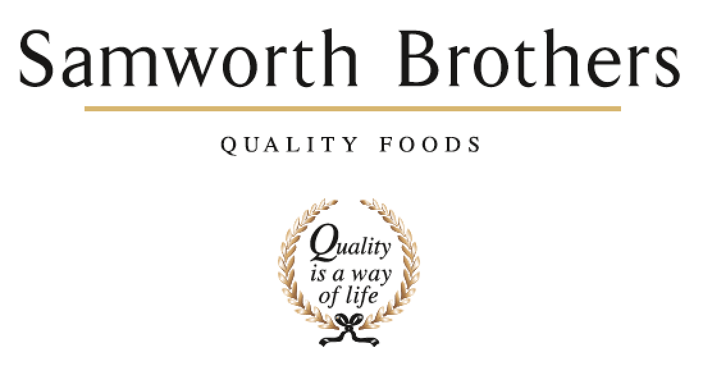

ROLE PROFILE
Job title | Engineering Manager | Date
Business
Department
Location
ROLE SUMMARY
To lead, develop and manage the Engineering function for Melton Foods site, including bakery maintenance and site services as well as capital projects. Support business growth and continuous improvement through development of strategic and robust Engineering ways of working which align with the overall Samworth Brothers strategy for Manufacturing Excellence & Engineering, including – People Development, Capital Management, Asset Care and Maintenance, Reliability, Maintenance Cost and Health, Safety & Environmental compliance.
Overall, provide leadership to the engineering teams, and work in collaboration with broader business teams and stakeholders to improve operational performance and contribute to sustainable business success.
REPORTING STRUCTURE
Reports to | Site Director
Deputy
Direct & indirect reports | Project Engineer, Site Services Manager, Maintenance Manager
Key internal stakeholders | Bakery Senior Leadership Team, Manufacturing Excellence team, Site Director, FTG Directors
Key external stakeholders | Engineering contractors

SKILLS & ABILITIES
Leadership & Management
- Act as a role model for the Samworth Brothers Values and Ways of Working and encourage teams to share in our Purpose of “We do GOOD things with GREAT food”.
- Work collaboratively with the leaders and managers of the business to build a values-based culture, delivering on the Culture Framework and ensuring that results are achieved with people at the heart of every decision, and consistent focus is given to providing a positive experience for colleagues.
- Take a long-term view of all business relationships and pro-actively build relationships at all levels. Role model and develop relationships which inspire trust between colleagues, teams, and departments, and with external stakeholders.
- Lead and champion change. Manage, develop, and control the impact of organisational change within the operation, to maximise benefit and minimise any negative impact. Encourage the view that change is a necessary and valuable part of business progress.
- Pro-actively take personal responsibility and accountability to fully understand challenges, seek solutions, and facilitate collaborative working. Look to senior peers for guidance as appropriate.
- Continually look to improve own performance and capability by linking personal objectives to support the business, and seek learning and development opportunities. Take ownership for own Continuing Professional Development (CPD)
Health & Safety, Responsible Business
- Lead a culture of behavioural safety, encouraging shared ownership of safe working practices and risk mitigation.
- Ensure the risk assessment plan is developed and completed for the Engineering function, that safe systems of work are in place and followed, and that identified risks and hazards are appropriately managed, including effective isolation and lock-off procedures.
- Ensure that any risks or opportunities for improvement which are identified are addressed promptly and comprehensively.
- Act as a role model of responsible behaviour. Challenge any unsafe behaviours and lead the teams to improve standards.
Food Safety & Quality
- Be accountable for food safety, ensuring any corrective action identified through incident follow-up, audit or Continuous Improvement (CI) actions are delivered promptly as a sustainable solution.
- Work closely with the Technical and Operations teams to ensure all Engineering work is carried out in accordance with food safety best practice, and to highlight, resolve and/or advise on any food safety issues or concerns in which machinery, facilities or engineering practice is a factor.
Engineering Operations & Performance
- Produce and deliver effective Engineering plans. Ensure they meet the needs of the business and the manufacturing operation, to encompass buildings, plant, and equipment assets. Collaborate, communicate, and consult to ensure that plans recognise external developments in legislation, regulatory and technical standards, and internal/Group changes, and that stakeholders are advised accordingly of amends made to the Engineering plans.
- Drive collaboration between departments and cross functional teams to pro-actively manage resources and co-ordinate plans to achieve maximum operational performance.
- Set and ensure high standards for Engineering, setting clear expectations for quality of work and internal customer satisfaction, monitoring, and following up with corrective action as required.
- Be accountable for compliance with legal, regulatory and Company requirements including robust management of statutory tests and inspections.
- Ensure continuous preparedness for internal and 3rd party audits and achievement of the highest grade against external standards, and to demonstrate this at audit.
- Host auditors and visitors to the site as required, and demonstrate a thorough knowledge and understanding of the people, processes, and standards. Involve team members, where appropriate, to demonstrate team engagement and empower others.
- Manage the life of building, plant and equipment assets through pro-active planned maintenance and strategic asset-care practice from purchase of new through to replacement or upgrade.
- Be accountable for contractor management, including selection and approval, induction and permit to work, and ensuring that adequate supervision of work performance and safe practice is in place.
- Monitor and review Engineering costs. Plan, prepare, analyse and monitor financial budgets and forecasts. Identify opportunities to minimise costs / increase profit.
- Monitors and reviews Engineering performance. Reviews performance against all Key Performance Indicators (KPIs) and re-align, re-evaluate where necessary to maximise effectiveness.
- Identify areas for improvement of Engineering practice to support overall efficiency and quality, and food safety. Deliver Continuous Improvement (CI) projects and Profit Improvement Plan (PIP) objectives through improvement teams, ensuring recommendations are implemented.
- Identify, develop and deliver a 3-5 year rolling capital plan to support the business to include costs, benefits and deliverables as well as key stakeholder needs.
- Manage delivery of capital projects to agreed standards and timelines including forming and leadership of project teams, supplier evaluation and sourcing, stakeholder relationships, and post-project evaluation.
- Drive improvement in energy and water efficiency, and effluent reduction through monitoring and targeting systems, multifunctional action plans and working with external parties. Also review and mitigate risks to supplies of utilities and put contingency plans in place.
People Management
- Facilitate effective communication between teams, other departments, and other sites.
- Address complex Employee Relations (ER) issues promptly and in line with Company values, People policies and processes, and best practice and coach line managers to do the same.
- Assess forecasted production demands to ensure team resource plans meet business needs and provide for future skills requirements. Anticipate peak labour demand and periods of low availability and plan ahead accordingly for overtime and/or contractor requirements.
- Take accountability for fair and ethical management of your team in line with Company rules and Working Time Directive, ensuring line managers are taking a forward-thinking and supportive approach to the management of colleague leave, breaks, overtime and working hours.
- Be accountable for overall attendance and wellbeing, understanding any patterns or recurring issues, and taking action to address any contributing factors in the workplace. Act as a role model, ensuring that colleague wellbeing is a clear priority for the teams, and encourage an open and supportive culture. Coach line managers to be pro-active and supportive in encouraging attendance and managing absence. Manage complex and long-term absence cases with support from People team and Occupational Health.
- Be accountable for the people development and succession plans - monitor skills and capabilities against business requirements and put in place action plans which continually enhance business performance and support internal career progression. Ensure that line managers and colleagues fully utilise the development tools and resources.
- Be accountable for performance of team members; coach, delegate, empower, and motivate people to achieve goals. Build and lead high performing teams, leveraging the performance enhancement and talent & succession tools to unlock potential and support internal career progression.
- Lead and develop the Continuous Improvement (CI) approach as an embedded way of working. Support the development and delivery of CI initiatives and projects, in line with our values. Act as a mentor and facilitator to colleagues leading their own improvement projects, guiding them to deliver tangible benefits and sustained adoption of improved methodologies.
- Develop high performing teams through effective people management and development, recruitment, retention, and succession planning, using the toolkit of People processes and practices and coaching line managers to do the same. Be pro-active in creating a culture in which each colleague feels that they matter. Review colleague feedback from annual surveys, exit interviews, etc to form and drive action plans which increase engagement and enhance colleague experience.
Communication
- Provide an inspiring strategic vision, creating ownership and driving high performance and sustainable value.
- Communicate in a clear and confident manner that involves and engages others, flexing between different styles to suit the audience and situation. Influence and engage across all levels of the business. Manage confidentiality and sensitive information appropriately and ensure all team members do the same.
- Deliver briefings and lead meetings, ensuring that information is effectively shared and cascaded, and solutions and actions are agreed. Offer clear direction on business and inter-departmental strategy.

KNOWLEDGE & UNDERSTANDING
Leadership & Management
- Demonstrate a clear understanding of your role and how as a senior manager, you are a role model for the Samworth Brothers Values and Ways of Working.
- Demonstrate knowledge of the Culture Framework and how it is delivered in the business.
- Have solid business acumen - understands the way business operates and how the moving parts work together to make it successful. Know how to read the progress of the business through its financial metrics and has awareness of the levers, risks and opportunities which impact profitable growth.
- Demonstrate understanding of the overall strategic objectives and the goals of other functions and departments and drive active support for these.
- Know how to deliver complex change, including communication and consultation with individuals, larger groups, and key stakeholders. Understand how to plan and structure change, identify interdependencies, monitor, and manage progress, engage stakeholders, etc.
- Know how to collaboratively shape effective multifunctional business plans which mitigate risk and enhance efficiency, and can apply problem-solving skills (i.e., define problem, cause & effect, identify actions and achieve sustainable results through standardisation) in a complex production environment.
- Understand the importance of continued personal and professional development (CPD).

Health & Safety, Responsible Business
- Have full knowledge and understanding of the Health & Safety and Environmental management procedures: - Safe Systems of Work, Risk Assessment, Accident Investigation & Reporting, Auditing Skills, Near Miss System, COSHH, Emergency procedures and behavioural safety approach.
- Demonstrate a sound knowledge of environmental sustainability and how to manage relevant factors in the operation.
- Know how to use the H&S and environmental management IT system.
- Recognise own responsibilities as a senior manager of health, safety and environment as per Company policy and have the knowledge to carry out and uphold the SSOW's, SOP's and procedures.
- Know the Occupational Health control measures and routine surveillance programme.
Food Safety & Quality
- Demonstrate clear understanding of the Food Safety and Quality Management Systems, Process Control documentation, Hygiene schedules and processes, HACCP, Audit standards, Personal Hygiene.
- Have an understanding of the manufacturing processes and key quality aspects to be observed, with particular focus on Critical Control Points and known key areas of challenge.
- Demonstrate clear understanding of all the Standard Operating Procedures (SOP's) and Key Performance Indicators (KPI's) for the operation.
- Demonstrate an appreciation of product knowledge, from understanding the ingredients involved to the customer specifications and related costings, production processes, etc.
Engineering Operations & Performance
- Know how to analyse and interpret business needs and information to make short and long-term Engineering and Capital plans, and how to identify and mitigate any risk to required results using critical thinking and contingency planning approach.
- Understand best practice Engineering in the context of food manufacturing, and know how to deliver consistent standards of all key components – safety, legal and regulatory compliance, asset care and maintenance, quality work, internal customer service, etc
- Understand the principles and methodologies of Continuous Improvement (CI), how and when to select and apply these tools and techniques until best practice is sustained, and can guide others to do the same.
- Know how to scope, plan and deliver large capital projects, working with multi-functional teams and external stakeholders.
- Know how to manage resources to achieve business objectives.
- Can demonstrate knowledge of all relevant legal, regulatory, audit standards and customer Codes of Practice.
- Understand the importance of own role on delivering internal customer satisfaction, and attaining and maintaining critical standards in partnership with other business functions.
- Have a clear understanding of the financial implications of decisions / actions.
- Know how to build, manage, and drive savings against a budget.
- Have good levels of numeracy; be able to interpret budgets, variances and financial and statistical data and identify necessary action.
- Know how to use all relevant IT software programmes and tools.
- Have a good knowledge of KPIs and measures. Ensure they are used to drive results in Engineering and manufacturing processes.
People Management
- Knows how to lead and manage people in a respectful, fair, and inclusive way in line with our Values and acts as a role model of good people management practice.
- Has a good knowledge of the Samworth Brothers People Policies and Processes, job roles and structure, and People Portal system.
- Know how to manage in line with the Working Time Directive, Company policy, as well as the Ethical Trade Initiative (ETI) Base Code.
- Know how to apply the absence management policy and processes in a pro-active and supportive way to enhance colleague attendance.
- Understand the factors which impact colleague wellbeing and know how to support colleagues in ways which balance with business needs, and how to signpost to additional support when needed.
- Know how to effectively utilise the Samworth Brothers tools - Talent & Succession toolkit, Performance Enhancement process, including Ways of Working, Learning Toolkit and the training and development opportunities.
- Understand how to use a coaching style, empowering others to deliver results and develop understanding through personal accountability. Be able to clearly articulate the methodology and models behind this approach.
- Know how to conduct a fair and equitable selection process, mitigating personal bias, to hire the most suitable candidate for the requirements of the role.
- Demonstrate knowledge and understanding of the Samworth Brothers Recruitment tools and process, talent & succession toolkit and exit interviews process.
Communication
- Know how to communicate effectively, to engage and motivate, adjusting the approach according to context and audience, and acts as a role model for effective communication, active listening, and feedback.
- Have good levels of literacy; be able to write and produce reports and documentation relevant for the role.
- Understand how to produce presentations to share ideas, engage the audience and garner support from key stakeholders.

QUALIFICATIONS, EXPERIENCE, TECHNICAL SKILLS
- Degree / HND or equivalent in Mechanical / Electrical Engineering.
- CDM trained desirable.
- NEBOSH / IOSH essential
- Project Management qualification desirable
- Formal management qualification essential
- Six Sigma green belt or above desirable

CORE COMPETENCIES, ATTRIBUTES & BEHAVIOURS FOR SUCCESS
Values People | Demonstrates the belief that people are our most important asset and central to the success of the organisation. Everybody should be treated with dignity and respect at all times.
Customer Focus | Demonstrates the understanding that the satisfaction of our internal and external customers is the foundation of our success
Collaborative Team Working | The willingness to act as part of a team and work towards achieving shared objectives through adopting best practice in line with PQP and Federalism.
Flexibility & Adaptability | The ability to change and adapt own behaviour or work procedures when there is a change in the work environment, for example as a result of changing customer needs.
Initiative & taking ownership | Steps up to take on personal responsibility and accountability for tasks and actions in line with PQP and Federalism.
People Management | The ability to understand people and their motivations, build good relationships with them and help them unlock their potential.
Decision making and judgement | In line with our guiding principles of PQP & Federalism, makes timely and informed decisions that take into account the facts, goals, constraints and risks that keep the organisation moving forward.
Commercial awareness | Demonstrates an understanding of the impact decisions and actions have on the organisation in line with PQP and Federalism.
Developing partnerships | The ability to establish formal and informal relationships inside and outside the organisation, and to anticipate and balance the needs of those whose cooperation is needed for the long-term success of the business.
Engaging others through change | The ability to communicate a compelling vision throughout the organisation, generating genuine motivation and commitment and to act as a sponsor of change.
Focussing on the future | Demonstrates enthusiasm about our future by identifying strategic issues, opportunities to drive sustainable, profitable growth, and managing risk.

