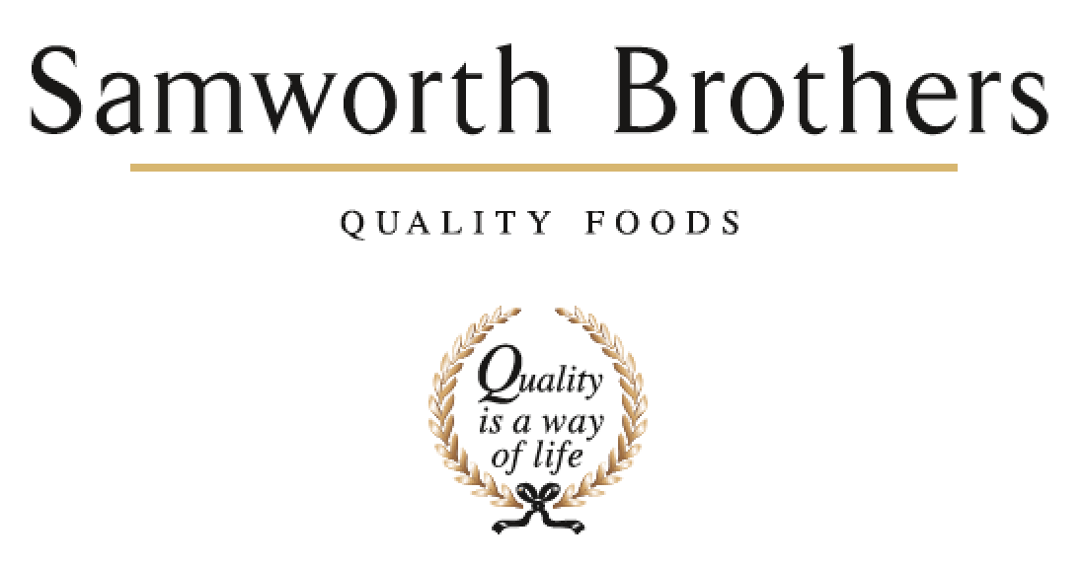

ROLE PROFILE
Job title | Trainer | Date | January 2025
Business | Samworth Brothers Manton Wood
Department | Operations
Location | Manton Wood
ROLE SUMMARY
Responsible for supporting the training function within the bakery and across all other departments as advised. Setting standards and providing instructions on GMP, Quality, H&S, training of SOP’s and SSOW’s for new and existing colleagues.
REPORTING STRUCTURE
Reports to | Training Manager
Working With | All colleagues
Key internal stakeholders | Department Managers, People Team, Team Leader, L&D Advisor

KEY ACCOUNTABILITIES AND RESPONSIBILITIES
- Conducting Company inductions to new starters, including Health and Safety and Food Safety.
- Ensuring core skills are trained in a timely manner to new starters and assessed at appropriate intervals, including Manual Handling, relevant SOP’s, etc.
- Maintaining high standards of communication with Managers, Team Leaders and colleagues, supporting the gap analysis.
- Ensure all necessary paperwork is completed in an accurate and timely manner and is uploaded on to department training matrices/Learning Management system. Supporting with tracking and driving training KPI’s as well as ensuring all training refreshers are planned ahead to ensure compliance.
- Develop and promote an excellent Health & Safety culture.
- Develop and promote an excellent Food Safety culture.
- Work closely with stakeholders to ensure SOP / SSOW training is created/updated as and when required.
- Ensure all colleagues understand and are signed off on all procedures to ensure compliance with Health & Safety, Food Safety and operational ways of working.
- Provide training and sign off support for all CCP operatives and update CCP matrices.
- Liaise with the Training Manager on the timing and delivery of programmes over and above bakery compliance.
- Where appropriate train and assess competency on equipment within the bakery.
- Any other reasonable request, including on-line work/training.

Required

Good basic IT skills & ideally experience of systems such as MS Excel and PowerPoint.
Accurate and organised in administration.
Able to prioritise a busy and varied workload.
Ability to work with internal stakeholders to achieve objectives.
Excellent communication skills both verbal and written.
Flexibility around meeting the requirements of the role.
Advantage

Food Safety / Health & Safety qualifications up to level 3
Food & Drink industry experience

CORE COMPETENCIES, ATTRIBUTES & BEHAVIOURS FOR SUCCESS
Competency | Descriptors
Values People | Demonstrates the belief that people are our most important asset and central to the success of the organisation. Everybody should be treated with dignity and respect at all times.
Customer Focus | Demonstrates the understanding that the satisfaction of our internal and external customers is the foundation of our success
Collaborative Team Working | The willingness to act as part of a team and work towards achieving shared objectives through adopting best practice in line with PQP and Federalism.
Flexibility & Adaptability | The ability to change and adapt own behaviour or work procedures when there is a change in the work environment, for example as a result of changing customer needs.
Initiative & taking ownership | Steps up to take on personal responsibility and accountability for tasks and actions in line with PQP and Federalism.

