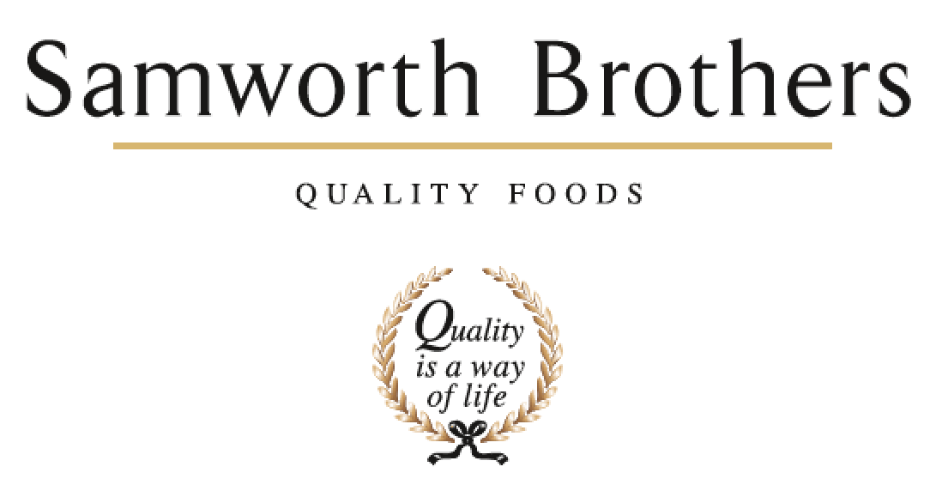

ROLE PROFILE
Job title | Snr. Product Development Manager | Date | August 2025
Business | Samworth Brothers
Department | Commercial
Location | Kettleby/Saladworks Bakeries
ROLE SUMMARY
As a Product Development Manager your purpose is to lead your PD function to create, develop and deliver commercially viable products in line with our growth strategy. To lead development and innovation in the function, creating and developing (through teams) commercially viable new thinking in line with our growth strategy.

To work with your team to initiate and manage projects from concept idea (or brief) to handover, with a supporting role until launched in stores (via process teams). Driving and supporting the development of new concepts and refreshing and optimising existing products following a development gate process working cross functionally in partnership with the insight, category, commercial, technical/process, production and procurement functions.

As a manager of the function you will support and drive the R&D vision and strategy for new product development that aligns with the company’s broader business objectives, market opportunities, and long-term growth goals across private label, brands and licensed brands.

You will support and drive a one-team environment where people bring energy, excitement, learning and sharing together, enabling talent to thrive. Supporting the development of and championing one way of working so you, your team and the wider teams you work alongside deliver at pace with discipline partnering with internal stakeholders to support business growth and profitability.

As a manager of the function you will work with the Head/Director to support and drive an internal and external culture of innovation (product direction), leading and supporting the initiation and delivery of ongoing pipelines (at times in partnership with the innovation and brand teams) of opportunity that deliver in the short and medium term while working alongside operational and technical teams to enhance performance and inspire cultural transformation, prioritising and championing cross functional working.

REPORTING STRUCTURE
Reports to | Head of Innovation and Development
Direct & indirect reports | Senior Technologist, Development Technologists, Development Chef
Key internal stakeholders | NPD Managers, Senior Technologists, Development Technologists, Senior Chef, Development Chef, Junior Chef, Commercial & Category Teams, Costing Teams, Technical and Process, NPD Sourcing Specialists & Procurement
Key external stakeholders | Retailer Product Managers, Chefs & Technologists. Suppliers.

KEY ACCOUNTABILITIES AND RESPONSIBILITIES
Lead and drive account specific product development pipelines and process from the kitchen as defined by the business strategy, in line with all customer and internal briefs. This role covers products made across both bakeries and working cross functionally with technical, process and operations to ensure alignment through the stage & gate process. Drive and advocate cross functional working with all site based departments to ensure alignment.

This role encompasses being the main business (internal/external) product development contact and commercial support for all relevant retail, B2B & brand projects.
Ensure that the team follows an PD Launch and critical path process to ensure launches are kept within company objectives and products are launched to a high standard in a timely manner.
Own/oversee customer critical paths from brief to product handover to process, ensuring engagement at all stages with relevant Samworth colleagues to ensure adherence to timeframes and that all challenges are met with a proactive resolving approach.
To co-ordinate all activities of the PD team and support functions to ensure that all internal and external meetings are implemented. Communication and visibility to all is key, ensuring all projects are delivered within key dates and timelines.
This role also encompasses identifying and evaluating global and local insights and food, ingredient and packaging trends in conjunction with the internal insights, innovation, category and commercial teams working with and through development chefs to support the business vision and customer strategy within a rolling 2-year horizon.
As a customer-facing role the job holder is expected to lead/support the insight, category, and commercial account managers when presenting idea/food opportunities and follow up meetings with the support of the senior technologists (presentations and customer visits)
Liaise with Ingredient sourcing specialists and packaging executives to keep abreast of future innovations and ensuring all raw materials and packaging is available for product development and submissions.
Where applicable, support future thinking working relationships in conjunction with brands, PL, insights, category and commercial functions building strong working relationships (a triangle approach) with central insights and category teams building future thinking pipelines that lead with consumer insight.
Drive and influence thinking and decision making internally and externally (being comfortable challenging and working in the grey at times)
Nurture and create cross functional working groups and relationships so innovation is part of everyone’s role, language and ownership.
You will work cross functionally in partnership with the Commercial, Category, Sourcing and Procurement functions, production and technical/process teams in the development of innovation from concept through to launch where applicable.
Where applicable own the PD part of customer/brand/licensing innovation project critical paths from brief to product handover to process, ensuring engagement at all stages with relevant colleagues to ensure adherence to timeframes and that all challenges are met with a proactive resolving approach.
Drive the translation of strong consumer concepts into winning commercial propositions via robust business cases. Overseeing handovers of innovation thinking/opportunities where being developed and managed by the PL teams
Co-ordinate all activities of the innovation team, and support wider functions to ensure that all internal and external meetings are implemented. Communication and visibility to all is key, ensuring all projects are delivered within key dates and timelines.
Ensure the team adheres to safe ways of working and site procedures.

Support the team in achieving daily tasks and ensure the correct level of training is supported by a well-managed PDP with reviews.

Drive and advocate cross functional working with all site based departments to ensure alignment through the development and stage & gate process.

Lead by example: Embody the desired culture and behaviours consistently demonstrating the values you want to
see in the team promoting open communication and collaboration by encouraging team members to share ideas, feedback, and concerns openly.

Recognise and celebrate achievements acknowledging both individual and team successes to boost morale and motivation.
Invest time in learning and team building - Providing opportunities for growth and development, such as training and mentorship, helping team members feel valued and invested in.

QUALIFICATIONS, EXPERIENCE, TECHNICAL SKILLS / KNOWLEDGE
Min 4 years' experience in food manufacturing environment.
BSc or equivalent in a Food related discipline.
Previous Project Management experience.
Proven track record of working collaboratively with others to deliver common goals

Competent with all major software packages.
Strong leader with good interpersonal and communications kills with the ability to communicate across departments/suppliers and external customers.
Strong organisational, and project management skills to assist with critical path deadlines and project priorities.
Working knowledge of the factory and raw materials currently used on site.
Is able to effectively time manage - to structure the team's day efficiently with regards to differing priorities / workloads as well as working to tight deadlines.
Hardworking and passionate with an eye for detail.
Ability to problem solve

CORE COMPETENCIES, ATTRIBUTES & BEHAVIOURS FOR SUCCESS
Competency | Descriptors
Values People | Demonstrates the belief that people are our most important asset and central to the success of the organisation. Everybody should be treated with dignity and respect at all times.
Customer Focus | Demonstrates the understanding that the satisfaction of our internal and external customers is the foundation of our success
Collaborative Team Working | The willingness to act as part of a team and work towards achieving shared objectives through adopting best practice in line with PQP and Federalism.
Flexibility & Adaptability | The ability to change and adapt own behaviour or work procedures when there is a change in the work environment, for example as a result of changing customer needs.
Initiative & taking ownership | Steps up to take on personal responsibility and accountability for tasks and actions in line with PQP and Federalism.
Drive for Excellence | Knows the most effective and efficient processes for getting things done, with a focus on continuous improvement.
Resource Management | Effectively manages resources and cost drivers to achieve sustainable productivity and profitability.
Technical Expertise | Has the skills, knowledge and experience required to excel in own area of specialism and the willingness to further grow and develop.
Self-Management | Uses a combination of feedback and reflection to gain insight into personal strengths and weaknesses, so that own time, priorities and resources can be managed to achieve goals.

